**Exploring the influence of England’s change-of-use Permitted Development Right (PDR) policy:**

a quantitative analysis of the spatial patterns and resultant quality ramifications on housing delivered through the change-of-use PDR scheme in London

**Ian Chng**

August 2022

([Github Repository](https://github.com/ianchng/Dissertation.git))

Submitted in part requirement for the Master of Science in the Centre for Advanced Spatial Analysis, Bartlett Faculty of the Built Environment, University College London.

Submission Date: August 22, 2022

Supervisor: Dr Jonathan Reades

Module: CASA0010

Word Count: 11,549

**ABSTRACT**

The scope of the controversial change-of-use Permitted Development Rights (PDR) policy has been expanded over the years. Against a backdrop of heightened concerns surrounding housing quality post COVID-19, recent expansions to the PDR policy warrants a review of the location and types of dwellings being delivered through this policy. Noting that existing literature is mostly qualitative and focuses primarily on larger developments, this study adopts a quantitative approach. A series of spatial analyses and innovative data joins were used to investigate the distribution, quality and size attributes of PDR developments on a London-wide scale. The research verified the findings of existing case-study based literature surrounding the good accessibility but high pollution exposure of PDR developments, whilst clarifying that a lower number of PDR flats flouted England’s Nationally Described Space Standards. Interesting spatial patterns were also found for small PDR developments (projects delivering 10 units or less) that were glossed over by existing literature. With the findings, this paper highlights potential avenues for future research while also providing data-driven arguments for the implementation and fine-tuning of existing PDR policies. The importance of a data-driven, quantitative approach was also discussed, in light of the launch of Class E PDR developments that will see smaller developments that might escape scrutiny.

**ACKNOWLEDGEMENTS**

I would like to first thank my supervisor, Dr Jon Reades, for his continuous support throughout this research. The countless advice, inputs and assistance Jon has rendered over the past few months has been instrumental in helping me improve and ultimately complete this research. Special thanks also to Dr Jessica Ferm and Bonnie Buyuklieva for answering questions regarding their research, providing useful context and data for this paper.

I am extremely grateful to the open source community that have made available data, R-packages and tutorials for which this research is largely based on. This research would not have been possible without their generosity in providing these resources.

Finally, a large thank you goes out to my friends and family who have supported and motivated me through the four months of writing this dissertation.

**DECLARATION**

I, Ian Chng, hereby declare that this dissertation is all my own original work and that all sources have been acknowledged. It is 11,549 words in length.



Ian Chng, 17th August 2022

**CONTENTS**

1 INTRODUCTION 8

1.1 Background and Objectives 8

1.2 Research Question 9

2 LITERATURE REVIEW 10

2.1 Setting the context - The Global Housing Crisis and Impacts of COVID-19 10

2.2 The London Context and the English Planning System 11

2.3 Introduction to PDRs 13

2.4 Extension of PDRs 14

2.5 Purported benefits 15

2.6 Literature Review of PDRs 16

3 DATA 19

3.1 Datasets 19

3.2 Exploratory analysis of PDR data 20

4 METHODOLOGY 23

4.1 Outline of Methods 23

4.2 Objective 1: Distribution of PDR developments 23

4.2.1 Part 1a: Analysing Spatial Extent and Distribution of PDR developments 23

4.2.2 Part 1b: PDR clusters in relation to socio-demographic factors 25

4.3 Objective 2: Attributes of PDR developments 26

4.3.1 Part 2a: Locational attributes 26

4.3.2 Part 2b: Quality and size attributes 27

5 RESULTS 29

5.1 Objective 1: Distribution of PDR developments 29

5.1.1 Part 1a: Analysing Spatial Extent and Distribution of PDR developments 29

5.1.2 Part 1b: PDR clusters in relation to socio-demographic factors 33

5.2 Objective 2: PDR development attributes 36

5.2.1 Part 2a: Locational attributes 36

5.2.2 Part 2b: Quality and size attributes 38

6 DISCUSSION 46

6.1 Implications & Next Steps 46

6.2 Additional Inputs on Regulation and Covid-19 50

6.3 Limitations 50

7 CONCLUSION 53

8 REFERENCES 56

9 APPENDIX 67

9.1 Appendix 1: Planning Documents for 185 Uxbridge Road (LB Richmond, 2013) 67

9.2 Appendix 2: Planning Documents for The Broomhouse Studios (LBHF, 2013) 70

**LIST OF FIGURES**

Figure 2.1: Old and new Use Class Orders 14

Figure 3.1: Histogram of PDR developments, by units delivered 21

Figure 3.2: Box and whisker plot of PDR developments, by units delivered 21

Figure 5.1: KDE map 29

Figure 5.2: Number of PDR developments in each MSOA within London 30

Figure 5.3: Moran’s I z-values and corresponding Getis-Ord map 31

Figure 5.4: Bivariate Moran’s I 33

Figure 5.5: Tiled map of NO2 data 36

Figure 5.6: Pct of PDR developments that are within set distances of train stations 37

Figure 5.7: Proportion of glazing types 40

Figure 5.8: Box and whisker plot showing the distribution of average unit size 41

Figure 5.9: Broomhouse Studios development 43

Figure 5.10: Layout of 257D Burlington Road development 44

Figure 5.11: Stacked bar-chart showing the proportion of units flouting the nationally prescribed space standards (35sqm) 45

**LIST OF TABLES**

Table 3.1: Data used in the research 19

Table 5.1: Summary statistics for energy ratings 39

Table 5.2: Top and bottom 3 small and large PDR developments, by average unit sizes 42

# INTRODUCTION

## Background and Objectives

Change-of-use Permitted Development Rights (PDRs) (hereafter ‘PDR policy’) were first introduced in 2013 to allow the conversion of office buildings into residential uses, without the need for planning application (hereafter ‘PDR development’) (RICS, 2018). This policy was touted as a way to alleviate the housing crisis, by “tap[ping] into the potential of underused buildings to offer new homes for first-time buyer and families long into the future” (Lewis, 2015). Though widely criticised for their low quality and small sizes (Muldoon-Smith & Greenhalgh, 2016), the scheme was rapidly expanded to allow more use classes to be converted into residential uses. Most recently, the addition of class E to residential PDRs on 21 April 2021 enabled the conversion of cafes, restaurants, health centres and indoor amenity space into residential properties, renewing concerns surrounding impacts of this policy (Clifford, Dennett & Chi, 2021; Jones, 2021).

While a variety of literature have documented the impacts and types of homes the PDR policy has created (Clifford, Dennett & Chi, 2021; Bibby et al, 2018), most of the current research is qualitative in nature (Clifford et al, 2019; Ferm et al, 2020; Muldoon-Smith & Greenhalgh, 2016), seeking to understand the implications through selected case-studies and interviews. This study therefore attempts to analyse the PDR policy from a quantitative standpoint, utilising publicly available prior approval data to analyse the distribution and locational attributes of PDR developments, before innovatively joining this dataset with EPC data to get an overview at the scale of developments in London. In doing so, the study attempts to account for most PDR developments in the capital, giving a much more complete and detailed analysis of spatial, locational and quality attributes than previously possible.

This work seeks not only to improve current policy, but to help local communities objectively assess the suitability of this policy for their neighbourhoods (Local Authorities can apply Article 4 directions banning PDR developments) at a time where the media is placing particular scrutiny on PDR developments, highlighting the worst of such projects (Wainwright, 2020; Jones, 2021). The use of quantitative methods and spatial analysis to investigate PDRs is also gaining importance, as the newly extended Class E PDR policy might produce smaller-sized developments that are less readily identifiable than large office blocks conversions. This study can thus serve as a starting point for academics to identify areas of concern and developments of poor quality, for future in-depth research. Lastly, this research comes at a time when people are spending more time at home due to flexible and home working arrangements arising out of the Covid-19 pandemic, making it crucial to analyse the quality of these homes.

Given that London is the epicentre of the housing crisis in the UK, a focus on the city serves as a good indicator regarding the potential impacts of the PDR policy, on this crisis.

## Research Question

The aim of this report is to therefore ask:

*“How has the change-of-use Permitted Development Right (PDR) policy influenced the location and type of housing delivered through this scheme in London?”*

To answer this question, the report sets out two objectives, each consisting of two sub-objectives. Objective 1 involves understanding where PDR developments are located across London, by first analysing their spatial extent and distribution (objective 1a) before attempting to understand if there is any relationship between clusters of PDR developments and specific socio-demographic factors (objective 1b). Thereafter, Objective 2 seeks to investigate the attributes of PDR developments, first by looking at their locational attributes (objective 2a) before analysing their quality and size attributes (objective 2b). Though seemingly alike, 1a looks at the general distribution and clusters of PDR developments while 2b tests claims regarding the tendency of these developments being located in areas exhibiting specific characteristics.

# LITERATURE REVIEW

## Setting the context - The Global Housing Crisis and Impacts of COVID-19

From Auckland to Berlin, major cities across the ‘Global North’ are facing a housing crisis (Wetzstein, 2019). Describing it as the Global Urban Housing Affordability Crisis, Wetzstein (2017:3160) sees the crisis as an issue of (un)affordability, brought about by “the accelerating trend of housing-related household expenses rising faster than salary and wage increases in many urban centres around the world”. He charges the accelerated re-urbanisation of capital and people, the easy availability of cheap credit and growing intra-society inequalities as main drivers of the crisis (ibid.).

With housing demand far outstripping supply in many cities, two main outcomes have emerged:

1. Rapidly increasing house prices (ibid.)
2. Decreasing house sizes and quality, marketed mainly to the “low-cost” market (Malpass, 2021)

As the crisis intensifies, housing provision and affordability have sparked protests and dissatisfaction towards local policymakers at their inability to break away from neoliberal market-oriented approaches for housing delivery and reluctance to tame profit-oriented property developers to solve the crisis (Schipper, 2021 and Hamann & Türkmen, 2020). Local policymakers have consequently placed increased attention on solving housing issues, giving prominence to a political movement known as *Wohnungspolitik* or Building Politics, which traces its roots to Germany during the early 1900s (Harlander, 2018). *Wohnungspolitik* refers to regulatory and performance-related measures taken by the public sector to influence the production, distribution and management of housing and is rooted in the belief that housing provision cannot be left to the free market to ensure equitable results (ibid.).

Policymakers across the globe have resorted to a variety of solutions to tackle the housing crisis, depending on their local contexts. Gallent, Madeddu & Mace’s (2010) study of housing policies in Turin, Italy demonstrated how authorities preserved housing quality through regulations enforcing minimum floor space standards, ceiling heights and window dimensions. Alternatively, Wetzstein (2019:286) found that Singapore embarked on a “large-scale supply offensive” that boosted public housing deliveries, whilst facilitating an increase in land tender and sales processes aimed at increasing flats for the private housing market. In contrast, Berlin aimed to resolve the crisis by curbing excess demand for housing: The Misappropriation Act was introduced in 2014, allowing citizens to report infractions such as unauthorised Airbnb Rentals and leaving properties vacant (Vollmer & Kadi, 2018). A rental price break was also introduced to prevent profit-seeking landlords from charging rents over 10% above the local average (Wetzstein, 2019).

The issues of housing affordability and quality highlighted above have been made even more pertinent by the recent COVID-19 pandemic. Madeddu & Clifford (2021) describe how housing became multifunctional during the pandemic, expanding beyond a place of rest to include work, leisure and education. The increased amount of time spent within homes emphasises the importance of ensuring quality homes are provided (adequate space, communal areas, outdoor spaces), to guarantee the wellbeing of residents (ibid.). Similarly, Hubbard, Reades & Walter (2021) find that those living in smaller properties are less happy with homeworking, while also struggling with the lack of access to open spaces such as private gardens. COVID-19 has also highlighted the public-health implications of cramming people into tiny homes and compact neighbourhoods with inadequate space to facilitate social distancing (ibid.).

As homeworking arrangements look set to remain after the pandemic and public health officials seek to improve their responses to future pandemics, the issues of expensive and poor-quality housing remain important subjects of study.

## The London Context and the English Planning System

London shares many of the problems cities face with regard to the housing crisis - albeit to a larger extent, due to its global city status. Sassen (2005) describes global cities like London as being central to facilitating the flows of capital, labour, goods and information across the world. Facilitating these flows are an agglomeration of producer services such as financial institutions, consulting and accounting firms, which serve to further attract more investment, wealth and talent into the city (ibid.). This concentration of capital, financial and business networks present prospects of sustained growth, attracting overseas real-estate investors to these cities with the intention of making huge profits or using “property as ‘safe houses’ for wealth funds” (Colenutt, 2020:50). Because of its global city status, London has experienced the fastest long-term growth in average house prices of any European city (Edwards, 2016). While researchers generally agree that the housing crisis in London is an issue of housing under-supply, its solution is subject to debate (Gallent et al, 2017).

Researchers such as Colenutt (2020) and Barrett (2018) believe that solving the housing crisis involves tackling demand-side pressures, especially from speculative overseas investors seeking to make windfall profits from real estate. This could see the introduction of vacant property taxes or rent freezes to dissuade such speculative buyers (ibid.). As explained by Gallent et al (2017:2205), policies must “acknowledge the centrality of spatially unbounded investment demand and the flow of money... into housing as fundamental to the current crisis of housing affordability and access”.

Contrarily, other academics view the housing crisis as a supply-side issue, caused by a bureaucratic and inefficient planning system. Cheshire (2009) accuses the UK planning system of restricting land supply by imposing strict guidelines and ordinances that limit developments to brownfield sites, promote urban containment and restrict development density, while Hilber and Vermeulen (2014:14) claim that “house prices in England would have risen about 100 percent less, in real terms, from 1974 to 2008 (from £79k to £147k instead of to £226k) if, hypothetically, all regulatory constraints were removed.” In an interview with CentrePiece (2014:14) Cheshire further charged that “the [housing] crisis has nothing to do with foreign speculators but decades of planning policies that constrain the supply of houses and land”.

Since the 1990s, the UK has mainly adopted a supply-side approach to solve the housing crisis, aiming to reform and deregulate the planning system which they view as an obstacle to growth (Lord & Tewdwr-Jones, 2012). In recent years, this view has been reflected in the introduction of several white papers and reforms, as a means to encourage more development to solve the housing crisis. These include the 2012 National Planning Policy Framework which replaces “a thousand pages of national policy with around fifty, written simply and clearly” to make planning easily accessible to all (MHCLG, 2021), the 2020 Planning White Paper which proposes to simplify and quicken complicated planning processes to provide more certainty to developers (MHCLG, 2020) and expansions of change-of-use Permitted Development Rights (PDRs) since 2013 - the main focus of this paper.

## Introduction to PDRs

Permitted Development Rights (PDRs) enable certain changes to be made to a building, without requiring planning permissions (Grimwood, 2021). First introduced in 1947 alongside the English planning system, PDRs were conceived to prevent the planning system from being overwhelmed with minor development issues such as private driveway modifications (Booth, 2003). Instead of having planning permission granted by Local Planning Authorities (LPAs), PDRs are essentially blanket planning permissions granted by Parliament (Grimwood, 2021). Some PDRs may require prior approvals by LPAs, but these cover a limited scope of essential requirements such as flood safety (ibid.).

In recent years, however, the government has used PDRs as a tool for property developers to circumvent the planning system, in hopes of encouraging housing delivery and development to solve the housing crisis (Ferm et al, 2020). Unlike a full planning application, the nature of PDRs mean that developers are not required to submit detailed plans to LPAs and LPAs can no longer object the development based on its location, design or the potential impacts it might have on the surrounding communities or environment (ibid.). The lack of oversight has proved controversial as communities and academics decry the undermining of community participation (Muldoon-Smith & Greenhalgh, 2016), potential loss of key amenities (Bensted, 2021), loss of funding for affordable housing derived through Section 106 agreements[1] (LondonCouncils, 2015), potential decline in housing standards (Mercer, 2020) and the creation of residential areas in unsuitable locations (Clifford et al, 2019).

## Extension of PDRs

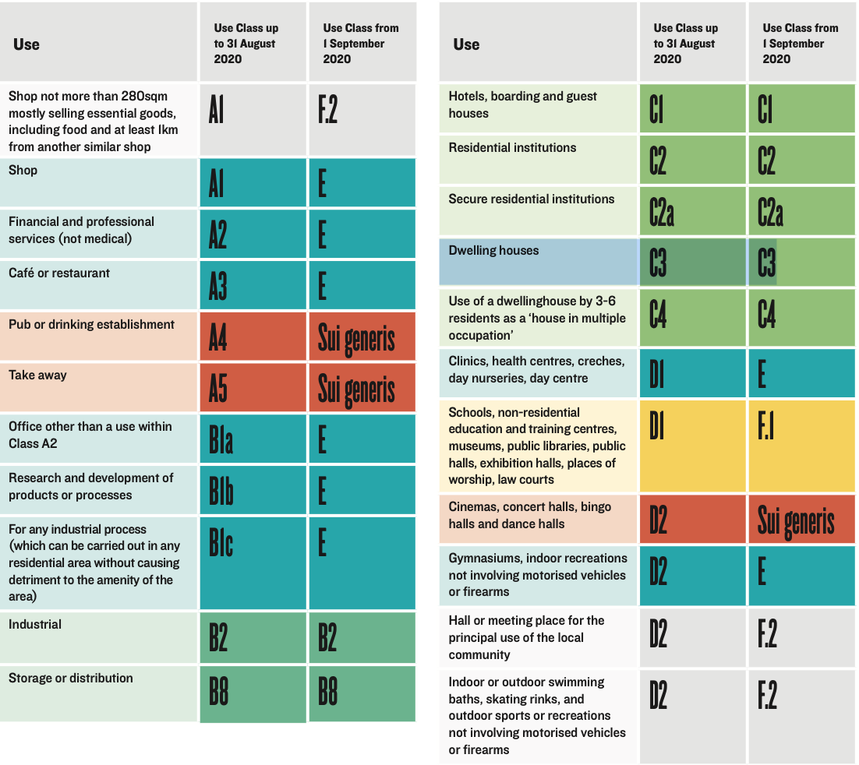

Figure ****2.****1: Comparison of old and new Use Class Orders introduced in August 2021 (Lichfields, 2021)

The first notable extensions to PDRs occurred in 2008 and 2010, which saw the increase in scale of extensions that could be made to residential, industrial and commercial buildings (Clifford et al 2018). In 2013, change-of-use PDRs were introduced - initially as a temporary 3-year trial to boost housing delivery - allowing developers to convert office buildings (use class B1a) into residential (C3), subject to a limited set of prior approvals covering issues such as noise, pollution and flooding impacts (RICS, 2018). Since April 2021, minimum space standards have been added to this list of prior approvals (PlanningPortal, 2021). Wider policy stipulations such as amenity provision and access to green space, normally enforced through the planning application process are no longer part of the decision-making process (Marsh, Chang and Wood, 2020). Despite proving highly controversial, the General Permitted Development Order (England) in 2015 made office to residential PDRs permanent (ibid.). In August 2021, a new Use Class E was introduced, comprising buildings that are categorised for commercial (previously A1, A2, A3), office (previously B1a, B1b), light industrial (previously B1c), service (previously D1) and amenity (previously D2) uses (Figure 2.1). This broad use class category greatly expanded the number of buildings that can be converted to residential uses through the PDR scheme (Clifford, Dennet & Chi, 2021).

## Purported benefits

The expansions of PDRs - in particular change of use PDRs - was touted by the government to solve the housing crisis in the following ways:

1. Open up new sites for the creation of affordable homes. In support for introducing change of use PDRs, former Minister of State for Housing and Planning Brandon Lewis (2015) commented that the expansion of PDRs “will mean we can tap into the potential of underused buildings to offer new homes for first-time buyers and families long into the future”.
2. A solution to the slow, inefficient discretionary-based planning system, which the government viewed as the main cause of the housing crisis (DCLG, 2012).
3. Increase predictability of development approvals for developers and reduce constraints imposed by the planning process (Lichfield, 2003).   
     
   The increased certainty and streamlined process would encourage developers to not only deliver more housing but enable them to deliver it within a shorter time span, putting affordable housing within reach of the wider community (DCLG, 2012).

## Literature Review of PDRs

Studies surrounding the impacts of PDRs have been somewhat limited. A systematic review of literature conducted by Marsh, Chang and Wood (2020) to investigate the impact of PDR housing quality on health yielded only 21 literature items that met their eligibility criteria. Of these, “eight were academic studies (four mixed methods, three qualitative research, one quantitative research) and the remaining 13 were grey literature (6 expert opinion, 6 reports, 1 documentary)” (ibid:4). Their review established a link between PDR conversions and health issues, demonstrating how common PDR development traits such as their small sizes, lack of amenity space and inappropriate location lead to health impacts like respiratory diseases and mental health problems amongst their occupants (ibid.).

To date, the most in-depth research surrounding PDRs has been a qualitative study conducted by Clifford et al (2018), where five LPAs across England were shortlisted (of which, two were in London - Camden and Croydon) because of their high rates of PDR and different built environment characteristics. Planners from these five LPAs were asked to provide a list of every prior notification for office-to-residential PDR conversions between 2013 and 2017 (ibid.). Site visits were then conducted for all 568 office-to-residential PDR buildings in the five LPAs to assess their conversion quality, amenity and to collect building data such as floorplans (ibid.). Looking at the two London LPAs, 72% of PDRs examined in Camden met national space standards compared to only 31% for Croydon (ibid.). Interviews with local councillors from these LPAs revealed a concern that housing delivered by PDRs “is not suitable or affordable to the borough’s residents” (ibid:22).

Further studying Clifford et al’s (2018) data, Ferm et al (2020) note that although PDRs increased housing delivery, the units tend to face issues of quality and were commonly situated in locations unsuitable for residential use. Across all the case studies, only 30% of PDR units met national space standards, compared to 94% of those delivered through planning application (ibid.). An example of a PDR conversion located in an active industrial estate at Leeds was used to demonstrate how the policy led to residential units being built in unsustainable locations (ibid.).

Following their initial investigation in 2018, Clifford et al’s (2019) detailed study of thirty examples of PDR Conversions found that only 13.6% of the units he analysed met nationally described space standards. Location wise, only 50% of the schemes were within 250m of some public or open space, with some in problematic locations such as beside a waste transfer station or located in front of an expressway (ibid.). That said, many PDR flats were found to be located in convenient locations, near public transport and services (ibid.).

With the expansion of PDRs to include Class E to residential conversions in August 2021, Clifford et al (2021) published a report detailing the potential impacts this ease of conversion would have on high streets, cautioning that local areas risk losing important local amenities to residential uses. Similar to previous studies, research was based on four selected LPAs, with information from Ordinance Survey Point of Interest data used as an indicator of the shops the policy expansion may affect (ibid.). Though beyond the scope of this dissertation, research has also been done on the impacts of PDR on planning practices and policy (Muldoon-Smith & Greenhalgh, 2016) and accelerated decline of office stocks (Derbyshire & Havers, 2014).

An issue in the PDR literature is the lack of quantitative work. The qualitative nature of research done thus far, while insightful, means that it is impossible to aggregate and analyse data pertaining to affordability, spatial patterns, size and other characteristics of PDR developments. To date, the qualitative studies on PDR developments focus mainly on the potential losses that the policy has inflicted on LPA affordable housing budgets (£42million) and planning fees (£22million) (Bibby et al, 2018), numbers surrounding the increase in PDR applications (Baker & Parker, 2018) and the price of PDR developments compared to those delivered through normal planning applications, on a per square foot basis (EGi, 2015). As Clifford et al (2019:1) acknowledged, the dominance of case-study, interview-based approaches “[does] not provide a comprehensive or systematic review of all the schemes typical in any particular area, but rather have been provided as exemplars of the types of schemes that are possible through permitted development rights.”

With studies simply focusing on the boroughs with the highest recorded number of PDR developments, existing literature has therefore potentially ignored wider trends and patterns that might exhibit at a London scale. No study sought to account for the prevalence of PDR developments within certain areas of London, opening up the opportunity for research on the socio-economic factors that might lead to the clustering of these developments in specific areas.

The above, therefore, opens several avenues in understanding the influence of the PDR policy, within the following themes:

*DISTRIBUTION -*

1. **Spatial extent and distribution** - where PDR developments are located and if there are patterns observed in their overall distribution?
2. **Distribution in relation to socio-economic factors** - is there any correlation between the distribution of PDRs and the socio-demographic factors of their surroundings?

*ATTRIBUTES -*

1. **Locational attributes** - case studies highlight the occasional development located near an industrial estate or polluting expressway, but how many of these PDR developments are in such locations? Moreover, are PDR developments generally more well connected to public transport than observed in the case studies?
2. **Quality and size attributes** - How do PDR developments fare in terms of quality? Are they mostly of very poor quality as reported in the media and seen in the case studies? Additionally, do PDR developments generally deliver small homes that are below nationally described space standards?

# DATA

## Datasets

This study employs primarily open data sources, as seen in Table 3.1.

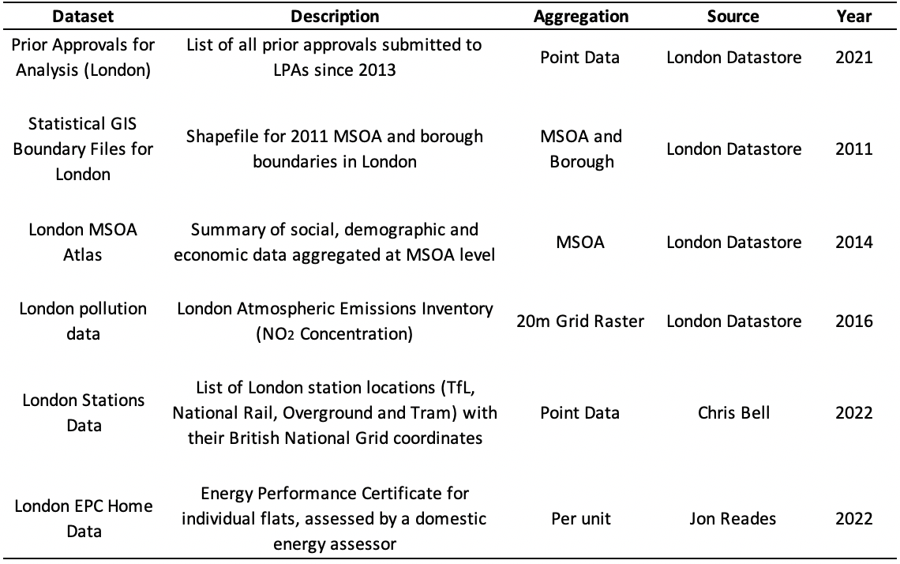

Table 3.1: Data used in the research

The Prior Approvals for Analysis dataset is an excellent way to identify PDR developments, given that developers wanting to perform an office/retail/takeaway/light industrial to residential PDR conversion are required by law to “apply to the local planning authority for a determination as to whether the prior approval of the authority will be required” (The Town and Country Planning General Permitted Development Order, 2015). This dataset includes both applications for prior approval and prior notifications (ie seeking of permission from LPA on whether prior approval is needed), so in principle all PDR applications that have been submitted since the scheme’s conception in mid-2013 can be identified. This dataset includes not only the PDR development, but also information regarding the proposed number of units for each development, enabling both attributes to be analysed.

Middle Super Output Areas (MSOAs) were used as the basic unit of statistical aggregation of data. Being more finely-aggregated than Wards but larger than LSOAs and OAs, MSOAs serve as a compromise that allows local-level differences to be observed while giving an overall London-wide view of prevailing trends. MSOAs are also the closest option England has for a statistical neighbourhood, making it a great way to analyse local impacts (Rae, 2020).

An exploratory analysis will first be done on the Prior Approvals dataset to better understand the spread and key characteristics of PDR developments in London. Following which, in-depth analysis will be conducted on the spatial distribution, locational attributes, quality and regulatory impacts of PDR developments by using the other datasets described in Table 3.1.

All data utilised within this research are open source and publicly available, making them compatible with prevailing data protection laws in the UK. No data surrounding identifiable persons was used, allowing further data processing to be done on the open data without much restriction (EC, 2018). Nevertheless, precaution was taken to ensure the data was processed responsibly, for the purposes intended by its publishers.

## Exploratory analysis of PDR data

An understanding of the PDR development data is needed, before in-depth analysis can be undertaken. Given that change of use PDR conversions are of interest in this research, offices, retail, takeaway, light industrial to residential conversions were identified from the dataset. As locational and quality attributes of PDR developments will be analysed, only completed developments will be considered in this research, unless stated otherwise in the methodology. PDR developments that have received prior approvals from Planning Authorities but that are not listed as completed will not be considered, as these applications might lack a finalised design, or even simply be speculative applications that developers have submitted to gauge what proposals Planning Authorities might accept from them (EGi, 2014). Repeated entries for planning applications and developments sharing the same point location were removed, to minimise duplicate entries.

A histogram (Figure 3.1) and box-and-whisker plot (Figure 3.2) were used to understand the distributions of PDR developments, in relation to the number of units they deliver.

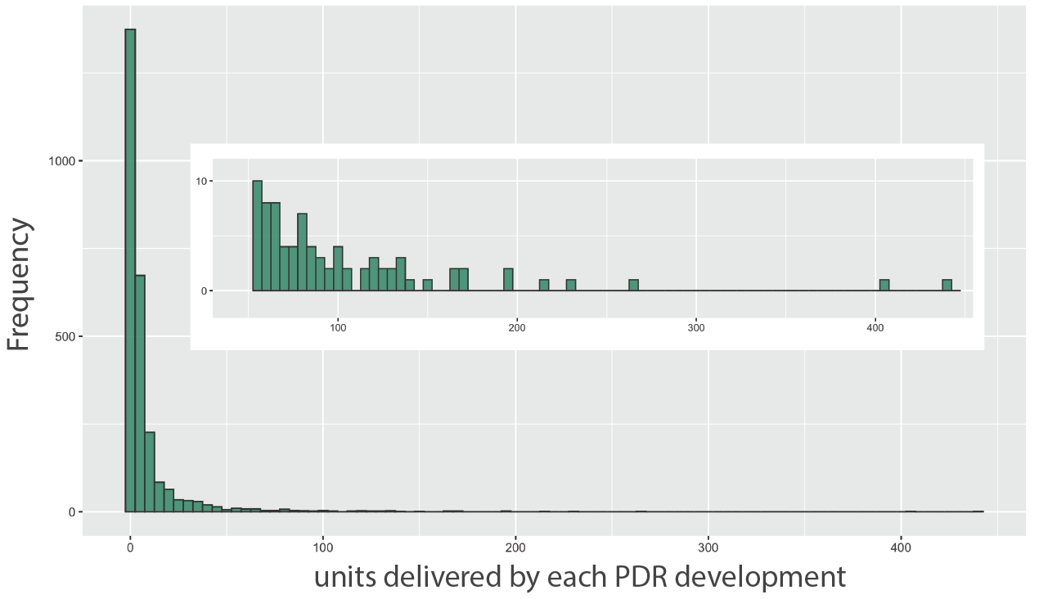

Figure 3.1: Histogram of PDR developments, by units delivered. Inset shows a zoomed-in view of developments delivering 50-450 units.

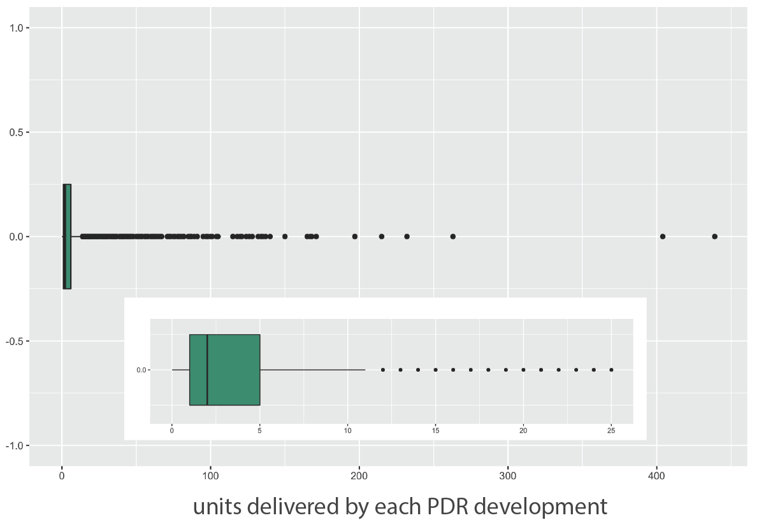

Figure 3.2: Box and whisker plot of PDR developments, based on units delivered. Inset shows a zoomed-in view of the plot, between 0-25 units delivered.

Considering all completed PDR developments from 2013 to 2021, Figure 3.1 demonstrates that even though there are some PDR developments delivering upwards of 200 units, an overwhelming majority of PDR developments deliver 10 units or less. Similarly, Figure 3.2 illustrates that the median PDR development delivers only 2 units. The “maximum" value of the distribution - shown in the box plot by adding 1.5 times the interquartile range to the upper quartile (Galarnyk, 2018) - is 11, meaning that developments delivering upwards of 11 units are outliers.

These findings differ from the dominant narrative in the media and existing literature, which have focused mostly on large PDR developments. News articles published by the Guardian and Financial Times highlight the quality issues surrounding large PDR conversions such as the 54-unit 5 Sydenham Road building in Croydon and 60-unit Newbury House in Ilford (Jones, 2018; Evans, 2018). Similarly, existing literature tends to focus on larger developments (Clifford et al, 2019), with the Estate’s Gazette report (EGi, 2015:3) including only “schemes of 10 or more units” in their methodology.

This focus on large PDR developments mean that the overwhelming majority of PDR developments have mostly been overlooked, warranting an in-depth analysis of this particular group of small PDR developments. Consequently, this analysis will split PDRs into small (developments delivering 10 units or less) and large (developments delivering over 10 units) developments, so that their differences could be studied, with more emphasis placed on the currently under-studied small developments.

Hereafter, reference to “small PDR developments” shall mean PDR conversions that deliver 10 units or below, while “large PDR developments” are PDR conversions that deliver 11 units or more in a single project.

# METHODOLOGY

## Outline of Methods

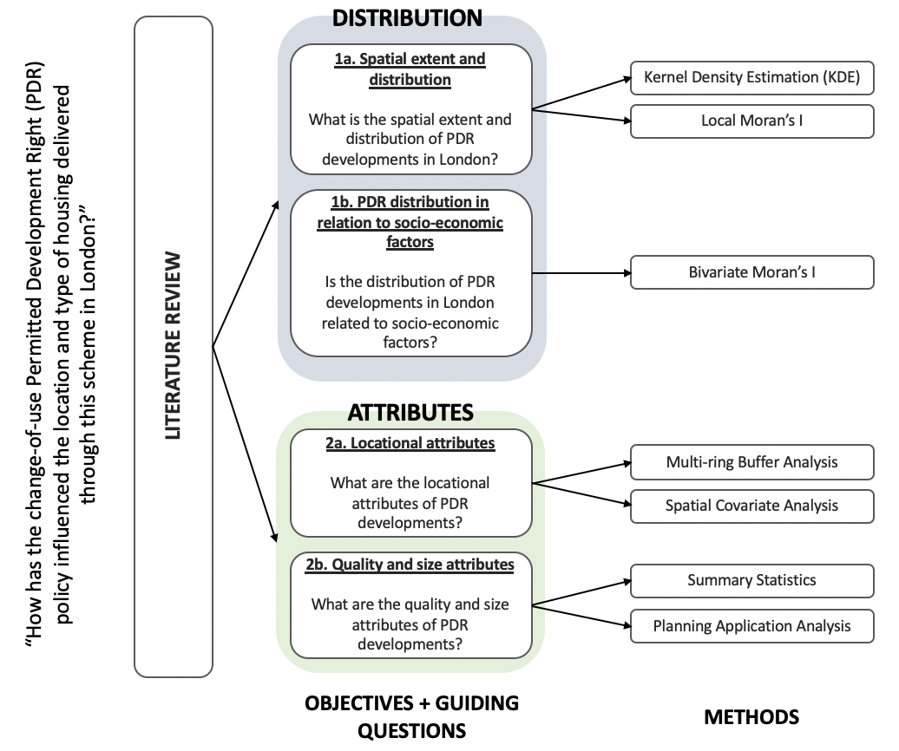

**Figure 4.1: Outline of methodology for each corresponding objective**

Figure 4.1 gives a summary regarding the objectives of this research, with the methods employed to meet each objective.

## Objective 1: Distribution of PDR developments

### Part 1a: Analysing Spatial Extent and Distribution of PDR developments

Information regarding PDR developments exist in the form of spatial points data, enabling point pattern analyses such as Kernel Density Estimation (KDE) to determine spatial patterns and distribution across London (Gartell et al, 1996). By calculating the density of point features around each output raster cell, KDE highlights areas where points are clustered and dispersed across a given area (King et al, 2016).

Research by Gallego-Valadés et al (2021) and Zhang et al (2013) have used this technique to understand the distribution of public housing in Valencia and Wuhan respectively. Adapting their methods, two KDE maps - one for small and one for large PDR developments, with bandwidth of 1000m - was plotted using PDR point data to identify where these developments were clustering across London, and whether there are different cluster patterns between the small and large PDR developments. The 1000m bandwidth was chosen by using Gallego-Valadés et al’s (2021) choice of 600m as a reference point, before making further adjustments and visual comparisons of different bandwidth settings to minimise under and over-smoothing (Wolff & Asche, 2009, cited in Krisp et al, 2009).

KDE maps present a good starting point to analyse spatial point data, as it allows local variations to be observed in a more detailed manner which aggregated data fails to achieve. That said, it is difficult to observe local trends within boroughs and neighbourhoods without aggregating the data.

Following the initial KDE analysis, PDR development point data was aggregated into their corresponding MSOAs, for a series of spatial autocorrelation analyses to further understand their distribution. Jenks natural breaks was used to classify PDR count into naturally occurring data categories (Longley et al, 2016). This algorithm groups data by reducing the variance within each data class, whilst increasing the variance between the other data classes, better highlighting trends on the maps (Jenks & Caspall, 1971).

Subsequently, Moran’s I (Moran, 1948) was used to identify the presence of geographical clustering, by measuring the similarity of a value in relation to its surrounding neighbours. This indicator produces a number between 1 (clustering; similar values stay together) and -1 (dispersion; similar values repel each other), with 0 indicating complete spatial randomness. Given that this indicator is global in nature, local Moran’s I was then calculated to better understand the spatial relationships between neighbouring MSOAs (Anselin, 1995). A spatial weights matrix based on queen’s case neighbours was created, defining MSOAs with a contiguous boundary and points as neighbours (Lovelace et al, 2022). Queen’s case was used as it is assumed that bordering MSOAs will largely share similar developmental contexts. A map demonstrating significant z-scores was produced, to highlight areas where similar values cluster or disperse in relation to neighbouring MSOAs.

As Moran’s I identifies only the clustering/dispersion of similar values, it is unable to provide information on the nature of the value (Rey et al, 2020). To ascertain whether MSOAs with a great number of PDR developments are indeed clustering (and not MSOAs with a small number of PDR developments), a map of local Getis-Ord Gi* values was plotted. A positive Getis-Ord value indicates a statistically significant cluster of high values (hot spot) whilst a negative value indicates a cluster of low values (cold spot) (Getis and Ord 1992, 1995).

### Part 1b: PDR clusters in relation to socio-demographic factors

Existing literature has described how many PDRs are marketed as cheaper alternatives for young professionals, resulting in their small sizes (Ferm et al, 2020; EGi, 2015). To ascertain the extent of these trends in London, this section investigates the association between the distribution patterns of small and large PDR developments and socio-economic characteristics of the environment they are located in.

Median property price was selected to investigate if PDR developments are more likely to be built in MSOAs with high house prices while the percentage of small households (one person or couples without children) was used to test if the claim that PDR developments are targeted at young professionals is true (Ferm et al, 2020). Lastly, population density was used to identify whether PDRs were located around dense city areas, to understand if this policy was promoting infill developments in popular areas.

Adopting a method that is widely prevalent in housing studies (Wyly and DeFilippis, 2010; Romão, 2017; Gallego-Valadés et al, 2021), bivariate LISA using Local Moran’s I indicator was utilised, relating the non-lagged variable (small PDR developments) with 3 identified socio-economic characteristics as the lagged variable (median property price in 2013, percentage of one person and couple households without children and population density). Relationships between the non-lagged and lagged variables are only considered if they meet the 95% significance level, with a cluster highlighted when the value of a specified location is more similar to that of its neighbours’ weighted average (spatial lag) than it would be in complete spatial randomness.

The output map will consist 4 colours where dark red and dark blue indicates MSOAs where both the non-lagged variable and lagged variable have high and low values respectively. Light red indicates high values for the non-lagged variable but a low value for the spatial lag variable, while light blue demonstrates the inverse.

This entire process was repeated with large PDR developments set as the non-lagged variable.

## Objective 2: Attributes of PDR developments

### Part 2a: Locational attributes

Clifford et al’s (2019) and Ferm et al’s (2020) case study concluded that a significant number of PDR developments were located alongside busy roads and industrial areas that are unsuitable for habitation. PDR developments, however, were also found to be conveniently located near public transportation stations (ibid.).

To ascertain the former, the covariate effects of NO2 pollution on the number of small and large PDR developments was investigated by performing a Chi-squared test of complete spatial randomness (CSR) using quadrat counts (Baddeley & Rubak, 2017; Kim, Garcia & Brewer, 2021). A raster map of NO2 pollution levels across London was tiled into 20 segments of similar pollution levels based on percentile, with tile 1 being the least and tile 20 being the most polluted area. The raster data was finely segmented, to ensure the areas around busy and polluted main roads do not get averaged out with their surrounding areas. Thereafter, the number of PDR developments falling into each segment was tabulated, before a Monte Carlo test of CSR using quadrat counts was performed to verify if any significant (95% level) spatial trends are present. Monte Carlo was used in place of the default chi-squared test on R’s spatstat as the dataset does not meet the conditions for a chi-squared test, which requires all cells to have values above 0 (McHugh, 2013). NO2 pollution was focused in particular as it is a good indicator of vehicular (Coppalle et al, 2001) and industrial pollution (Sudalma et al, 2015).

To verify the latter, a multiple ring buffer originating from all TfL and National Rail stations in London was plotted at 100m intervals between 500m to 1km distance to investigate the distance at which PDR developments are located from public transport stations (Zhang et al, 2013; Dubé et al, 2013). The percentage of small and large PDR developments that falls within each buffer can then be analysed, demonstrating whether these developments are indeed strategically located close to transport nodes. A separate 1500m buffer was also created for comparison with a study (Collinson, 2014) that found that 94% of all London homes were within 1500m of a train station.

However, the use of specified distance buffers has its drawbacks. It assumes a straight-line distance between developments and train stations even though this is rarely the case in cities. Nevertheless, short of doing a much more complex street network analysis, this remains a valid means of analysis adopted by many prior studies (Maantay, 2007).

### Part 2b: Quality and size attributes

The prior approvals for analysis dataset which was instrumental for identifying change-of-use PDR developments lacks data surrounding the size of PDR developments. Circumventing this, code provided by Reades (2022)[2] joins prior approval data with the Energy Performance Certificate (EPC) database. The EPC dataset comprises information on total floor area, window glazing type and energy rating at the individual flat level, giving insights into the size and quality attributes of PDR developments.

Flat size was of particular interest, since existing literature have reported that PDR developments are often tiny (Wainwright, 2020). Window glazing and energy rating was selected as a proxy for quality, as these attributes determine whether a flat has adequate sound and cold insulation - an issue many older buildings struggle with (Boardman, 2007).

Attempts to join both datasets yielded a probabilistic match rate of approximately 60%, given errors around data input by the Local Authorities and the fact that these datasets were not designed to be read together in the first place. Problems such as new building names and new postcodes being issued to redeveloped buildings makes matching planning application with EPC data difficult. The actual match rate, however, should be slightly higher as a manual search on some developments revealed that some developments were never completed, while others were double counted despite earlier efforts to remove duplicates. While not covering 100% of PDR developments, the data provides an adequate understanding of general PDR size and quality trends.

The obtained joined data was further cleaned by identifying unique EPC numbers through the LMK Key, before identifying addresses that had multiple LMK Keys attached to them. This could happen as homeowners might request for new EPC upon expiry of the old certificates, or to boost their homes EPC ratings after significant renovation works. To resolve this, only the latest EPC issue dates were considered for these addresses. Energy ratings were also converted to a numeric value with A being 1 to G being 7, allowing for easier data manipulation later. Average values for each attribute will be calculated for every development, with developments identified through their unit planning application number.

Summary data will be aggregated at development level and provided for the average floor size and energy rating. For glazing, data will be presented on a unit level as some units within the same development lack glazing data, potentially affecting the overall score if aggregated. The top and bottom 3 largest developments will also be listed, to given an overall idea of how some of these developments look. This will be done for small and large PDR developments separately, to identify possible differences in size and quality.

Lastly, the proportion of units that comply with the national described space standards will be analysed, for small and large PDR developments.

# RESULTS

## Objective 1: Distribution of PDR developments

### Part 1a: Analysing Spatial Extent and Distribution of PDR developments

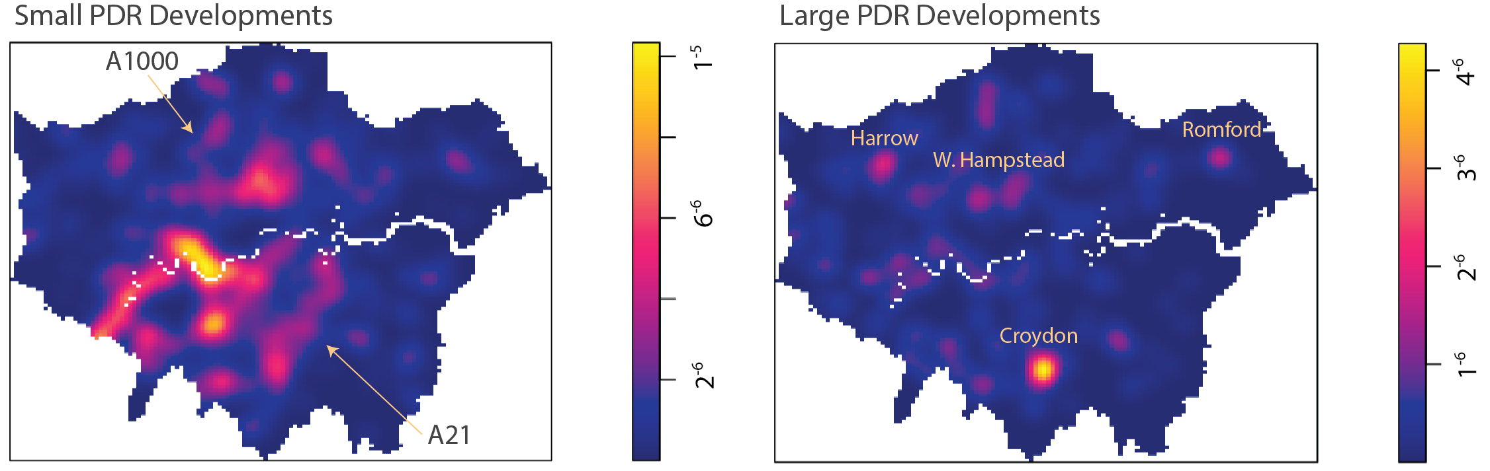

Figure 5.1: KDE map (σ = 1000m) showing the density of small and large PDR developments across London

Figure 5.1 demonstrates a clear clustering pattern for small PDR developments, particularly in southwest London and the northern city fringe. Clusters tend to be elongated, with a west London cluster following the River Thames, northern cluster trailing the busy A1000 Great N Road passing through Barnet and East Finchley town centres and a southern cluster following the A21 London/Bromley Road through Lewisham and Bromley.

Clustering for large PDR development is concentrated mainly within Croydon town centre, with secondary clusters observed across London’s regional centres such as Romford, Harrow and West Hampstead.

The absence of PDR developments within Central London in both maps is consistent with Grimwood’s (2021) observation that certain central London boroughs have successfully applied for Article 4 directions that ban the use of PDRs on grounds of protecting local amenity and well-being.

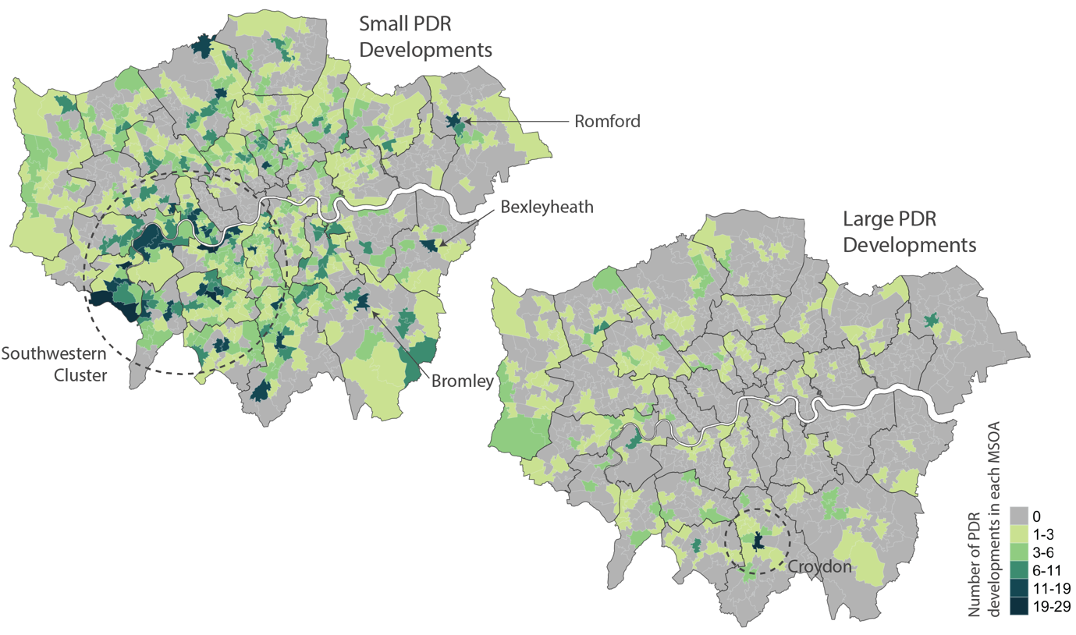

Figure 5.2: Number of small (left) and large PDR developments (right) in each MSOA within London

Similar trends of clustering are observed when PDR developments are aggregated at the MSOA level, as observed in Figure 5.2. That said, Figure 5.2 also demonstrates that there is a high occurrence of small PDR developments across London’s regional centres, with MSOAs in Romford, Bexleyheath and Bromley seeing over 29 instances of small PDR developments.

Figure 5.3 shows MSOAs with significant Moran’s I z-values, along with the corresponding Getis-Ord maps to ascertain whether high values or low values of PDR developments are clustering/dispersing. With reference to the Getis-Ord map, almost all of the observed Moran’s I patterns for small PDR developments and all the observed patterns for large PDR developments consist of hot spots, indicating the presence of a large number of PDRs developments there.

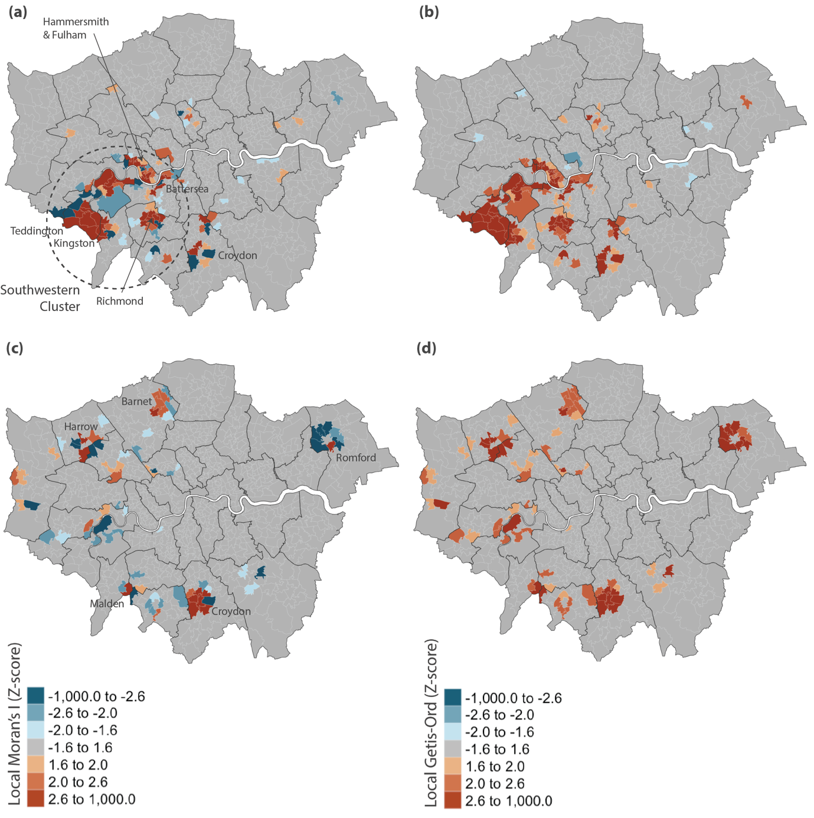

Figure 5.3: Moran’s I z-values for small PDR developments (a) and large PDR developments (c), along with corresponding Getis-Ord map for small (b) and large PDR developments (d)

Looking at the Moran’s I map for small PDR developments (Figure 5.3a), earlier observations of their clustering in southwest London is made even more prominent, with clusters of small PDR developments seen around Teddington, Richmond, Kingston, Hammersmith, Fulham, Battersea, Wimbledon and Hampton Wick. Croydon was the only area that observed a significant cluster of small PDR developments outside the southwest.

With large PDR developments (Figure 5.3c), significant clusters are observed across London’s various regional centres on the Moran’s I map - Croydon, Romford, Barnet, Harrow and Malden. These clusters tend to be surrounded by MSOAs exhibiting negative Moran’s I value, indicating that areas surrounding these town centres do not show similarly high numbers of large PDR developments. This is consistent with the typology of regional centres, which are centres of commerce and amenities, surrounded by areas of mostly low-density housing that lack office and retail shops that can be converted to housing through the change-of-use PDR scheme.

The above observations demonstrate some patterns with regards to PDR developments. Large PDR developments tend to cluster within London’s regional centres, which provide a supply of under-utilised 1960s-80s office blocks for conversion into residential uses. These trends have been studied and are well documented by the likes of EGi (2014) and Clifford et al (2018).

What is unexpected, however, is the distribution of small PDR developments. Small PDR developments were noticed to cluster around prime locations around London within neighbourhoods such as Kingston, Richmond and the city-west (Hammersmith/Fulham). This might be attributable to the high property prices within these neighbourhoods, making PDR conversions extremely profitable. Secondly, clusters of small PDR developments tend to have an elongated shape, possibly attributable to the conversion of offices and retail spaces along busy and accessible high streets across London. This trend is predicted to gain even more prominence, with the introduction of Class E to residential conversions in August 2021, allowing common high street shops such as restaurants, gyms and cafes to be converted to residential uses.

Lastly, the lack of large and small PDR clusters in east London might be due to the prevalence of Build-to-Rent developments in these areas (Buyuklieva, 2022), potentially saturating the market and making PDRs less profitable in these areas.

### Part 1b: PDR clusters in relation to socio-demographic factors

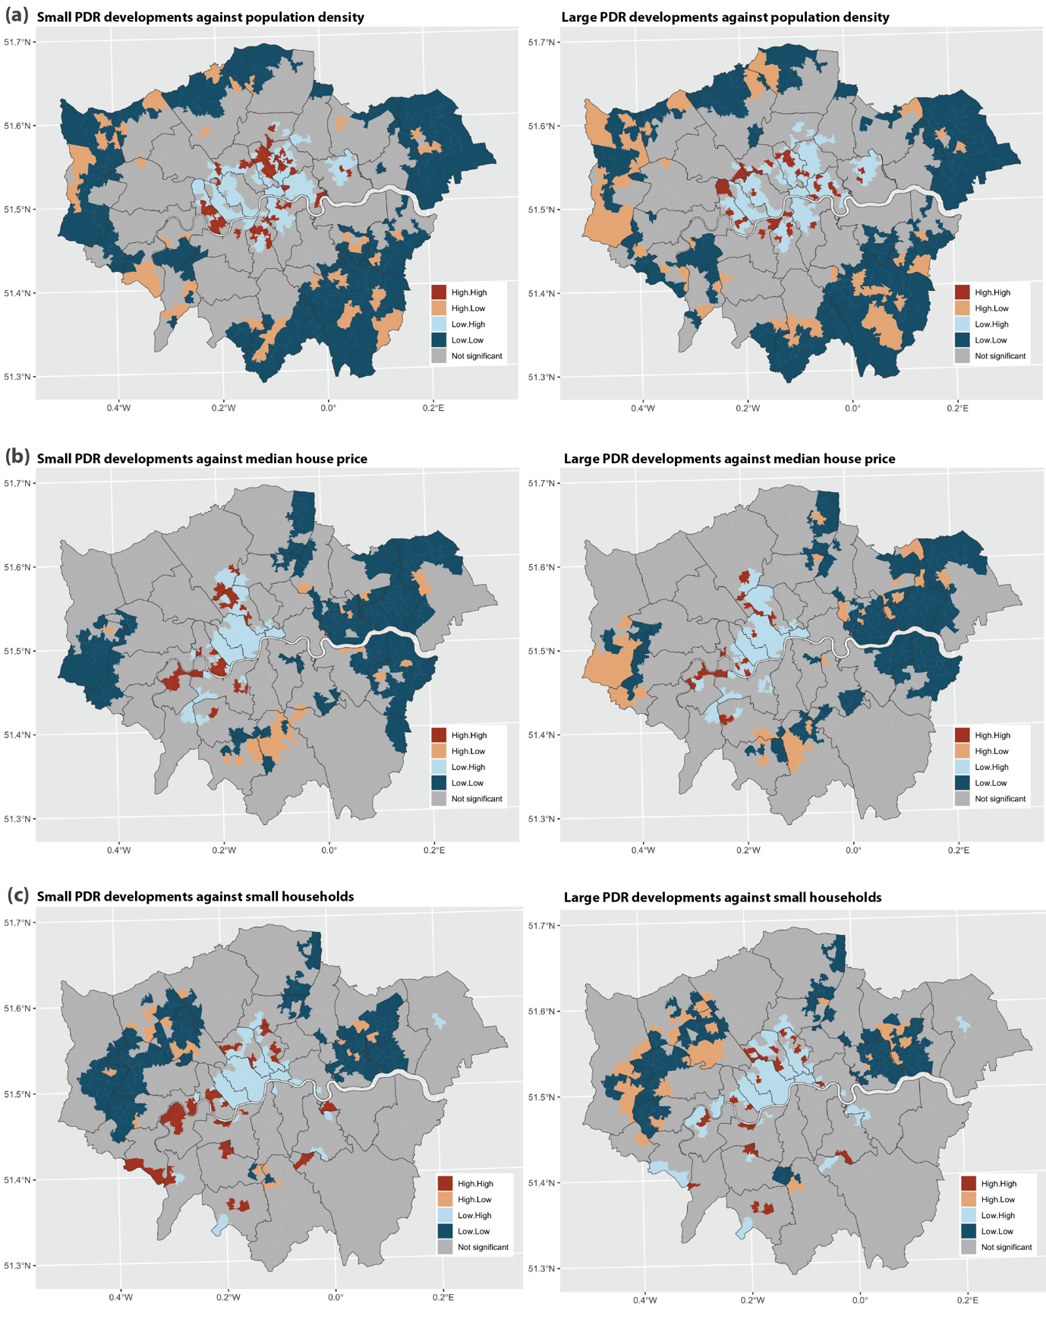

Figure 5.4: Bivariate Moran’s I comparing small (left) and large PDR developments (right) with population density (a), median house prices (b) and small households (c)

From Figure 5.4a, bivariate Moran’s I comparing PDR developments and population density does not exhibit any striking trends, with concentrations of small and large PDR developments correlated with neighbouring MSOAs that have both low and high population densities. This might indicate a lack of correlation between clusters of PDR developments and the population density of surrounding areas.

Looking at PDR v house price data (Figure 5.4b), concentrations of small PDR developments are surrounded by MSOAs with a high median house price (dark red) across southwest (Richmond/Wimbledon) London, city-west (Fulham) and the northern city fringe (West Hampstead). MSOAs that have a low number of small PDR developments but high median house prices (light blue) are generally located in central London, where Article 4 directions prohibiting PDR conversions are in place. There are a few areas where a large number of small PDR developments correlates with low house prices (light red), but these are mainly in regional centres like Croydon. Lastly, there is a noticeable cluster in the east where low rates of small PDR developments correlate with low land prices (dark blue).

Trends are less noticeable for large PDR developments, with high levels of developments correlating with both high and low median house prices in surrounding MSOAs and vice versa. An exception to this would be east London, where similar to small PDR developments, low levels of large PDR developments correlate with low levels of median house prices in surrounding MSOA tracts (dark blue).

With the PDR v small households map (Figure 5.4c), clusters where small PDR developments are correlated with a high proportion of small households in neighbouring MSOA tracts (dark red) can be observed across south west London and the northern city fringe. In contrast, low-low (dark blue) values are observed in outer west and east London. MSOAs with small PDR developments surrounded by tracts that have a low proportion of small households do exist (light red), but these, again are located in town centres such as Ilford. Similarly, low-high areas (light blue) are mainly locations that are covered under Article 4 directions.

For large PDR developments, there seems to be a significant cluster of developments correlated to neighbouring MSOAs with a low percentage of small households (light red). Low-low (dark blue) clusters do exist too, in outer east and west London, similar to the trend observed with small PDR developments. There also seems to be a limited number of MSOAs that have high-high (dark red) clusters as well, though not as prominent as compared to small PDR developments.

Observations within this section can therefore be summarised as follows. First, there does not seem to be observable trends between small/large PDR developments and the population density of surrounding areas.

Secondly, discounting areas with Article 4 directions and regional centres, Figures 5.4b and 5.4c illustrate a significant positive correlation between small PDR developments and house prices and the percentage of small households in surrounding MSOAs. While prior studies (Ferm et al, 2020; EGi, 2015) found that most PDR developments cater for small households as demonstrated by Figure 5.4c, Figure 5.4b goes further to show that small PDR developments are generally concentrated in areas with high median house prices.

Third, trends are less readily observed for large PDR developments across Figures 5.4a-c, as the main determinant for large PDR developments is the presence of large office blocks for conversions. These tend to be clustered in town centres, making correlations with median house prices and household sizes less prominent. In contrast, small PDR developments arise from the conversion of smaller office and retail shops that are more common across London, enabling developers to focus on areas which make economic sense.

Lastly, Figure 5.4b for both small and large PDR developments show a correlation between low PDR numbers and low median house prices, especially in east London. The lower median house prices and corresponding lack of PDR development in east London might be attributable to large swathes of land being freed up following the closure of London’s docks, making it difficult for PDR conversions to compete with new-build housing projects in these areas. In comparison, a densely built-up central and southwest London with high median house prices makes the conversion of office and retail spaces into residential uses profitable for developers, leading to clusters of PDR development there.

## Objective 2: PDR development attributes

### Part 2a: Locational attributes

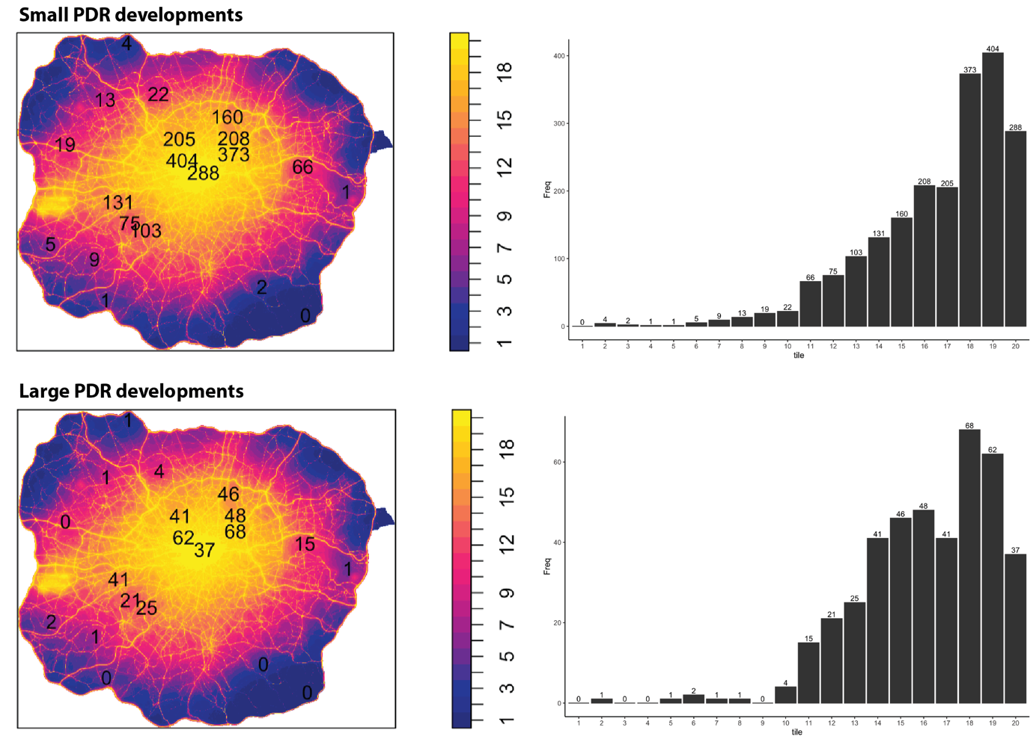

Figure 5.5: Tiled map of NO2 data (left), along with the distribution of PDR development falling within each tile (right). The top row shows data of small PDR developments whereas the bottom row shows that of large PDR developments

Figure 5.5 demonstrates that the mean and median NO2 pollution tile value for small PDR developments is at 16.6 and 18 respectively. Large PDR developments have similar values, with a mean of 16.1 and median of 17. Though large PDR developments perform somewhat better, both the mean and median values of small and large PDR developments fall within the top 20 percentile of areas that are most polluted by NO2 in London. To further illustrate the impacts of pollution, 78% of small and 72% of large PDR developments are located in the upper quartile of the most heavily NO2 polluted areas in London (tiles 15-20).

A Monte Carlo Test for CSR was run to verify the covariate effect of NO2 pollution on PDR developments, with the following hypotheses:

*H0: There is no covariate effect of NO2 pollution on the location of PDR developments in London*

*H1: NO2 pollution is a covariate effect on the location of PDR developments in London*

Given that the derived **p-value of 0.001 for both the small and large PDR datasets** was significantly below the 0.05 significance threshold, the null hypothesis can be rejected, indicating a statistically significant relationship between the NO2 pollution covariate and the distribution of both small and large PDR developments.

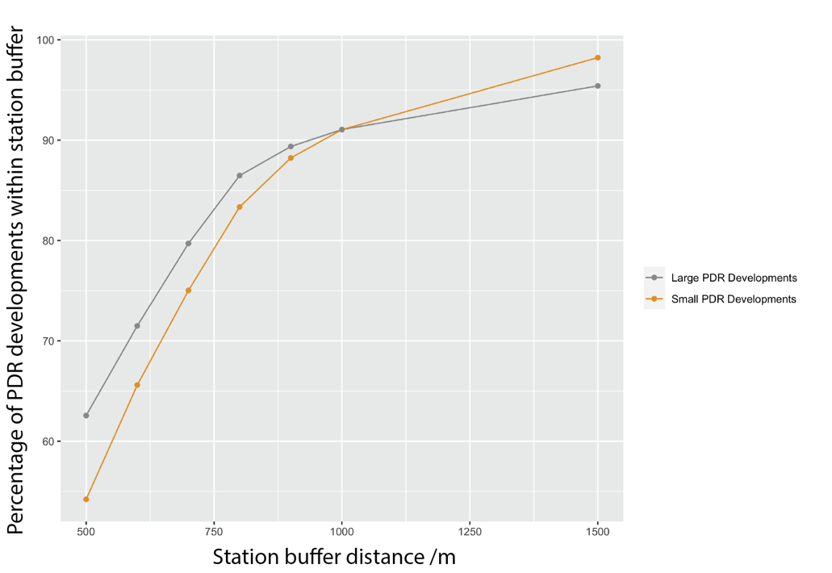

Figure 5.6: Graph showing percentage of small (blue) and large (orange) PDR developments that are within set distances of train stations

Figure 5.6 demonstrates that both small and large PDR developments within London are fairly well connected to the public transport train system. Over half of small PDR developments are within a 500m walk of the nearest train station, as compared to 62% for large PDR developments. This percentage increases to 91% for both small and large PDR developments when the buffer is increased to 1000m - a brisk ten-minute walk to the closest station. 98% of small and 95% of large PDR developments are within a 1500m walk of the closest train station. In comparison, Nationwide found that 94% of all London homes were within 1500m of a station, indicating that PDR developments are on the whole better connected than the average London home (Collinson, 2014).

The data presented in this section highlight a few interesting points: in general, both small and large PDR developments share very similar locational attributes and these developments tend to be located around well-connected places, albeit areas with high traffic flow and pollution, making them less-than-ideal for residential uses.

A possible explanation for these trends is that office and commercial developments are usually strategically located along busy roads or town centres, to maximise ease of access for employees and ensure high customer footfall respectively. While ideal for businesses, these locations may not be best suited for residential use due to the high noise and air pollution levels associated with busy streets. The PDR policy has therefore allowed the conversion of office and commercial-use buildings into residential developments with little oversight, in areas that are not ideal for habitation in the first place, potentially causing negative health impacts to residents.

### Part 2b: Quality and size attributes

After performing further data cleaning, 4371 units coming from small PDR developments and 9005 units from large PDR developments had matches with EPC data, leading to a match rate of 76% and 58% respectively. Although not ideal, the data here is sufficient to give a general understanding of certain size and quality attributes surrounding PDR developments.

Many units, however, lacked data surrounding their glazing type with only 30% of small PDR developments and 5.5% of large PDR developments returning a result. Summary data will nevertheless be shown, but caution should be taken when interpreting data surrounding glazing type.

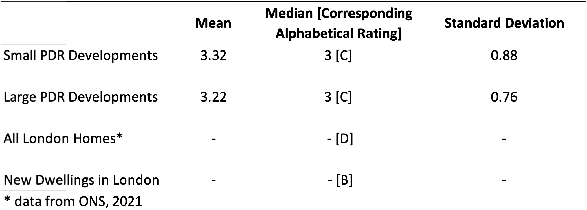

Table 5.1: Summary statistics for energy ratings for small and large PDR developments, compared with all London homes and new dwellings in London

Table 5.1 shows that average energy ratings for small and large PDR developments are similar, with a mean of 3.32 and 3.22 respectively. The relatively low standard deviation scores of 0.88 and 0.76 indicate that most developments cluster around the mean value.

The mean and median scores of around 3 translates to an energy rating score of C. This is higher than the median energy rating score of all London dwellings at D (ONS, 2021). However, PDR developments underperform when compared to new dwellings in London, which have a median score of B (ibid.).

A tiny but noticeable number of small PDR units (56 units or 1.2%) have energy ratings of F and G, indicating that little was done to improve their energy ratings during conversions.

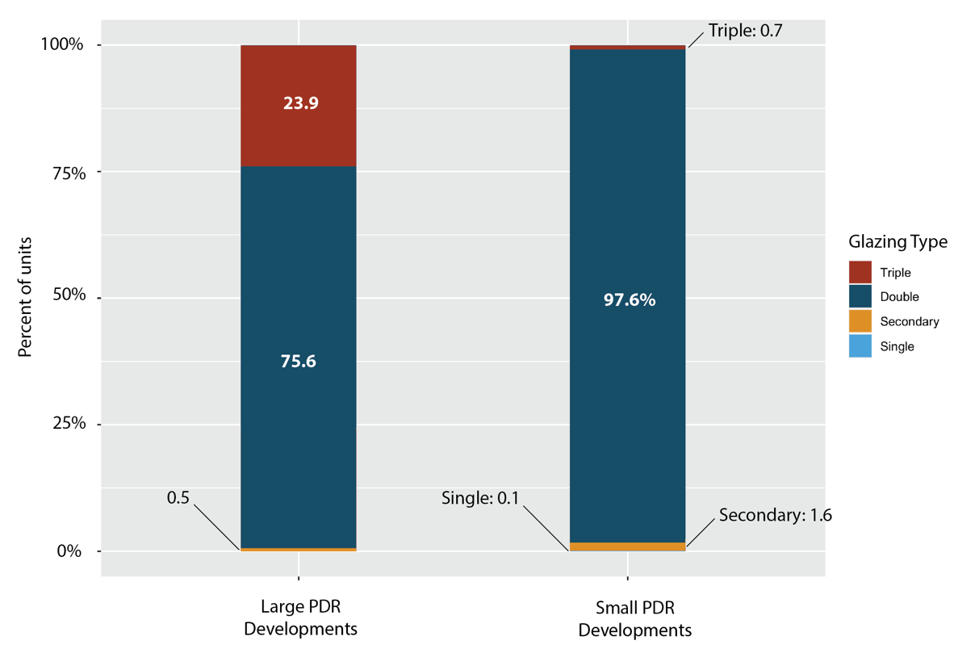

Figure 5.7: Stacked bar-chart showing the proportion of glazing types for units delivered by small and large PDR developments

As observed in Figure 5.7, a majority of small and large PDR developments have double-glazed windows. Compared to units delivered by small PDR developments that have little recorded provision of triple-glazing, a significant number of flats delivered by large PDR developments report triple-glazing.

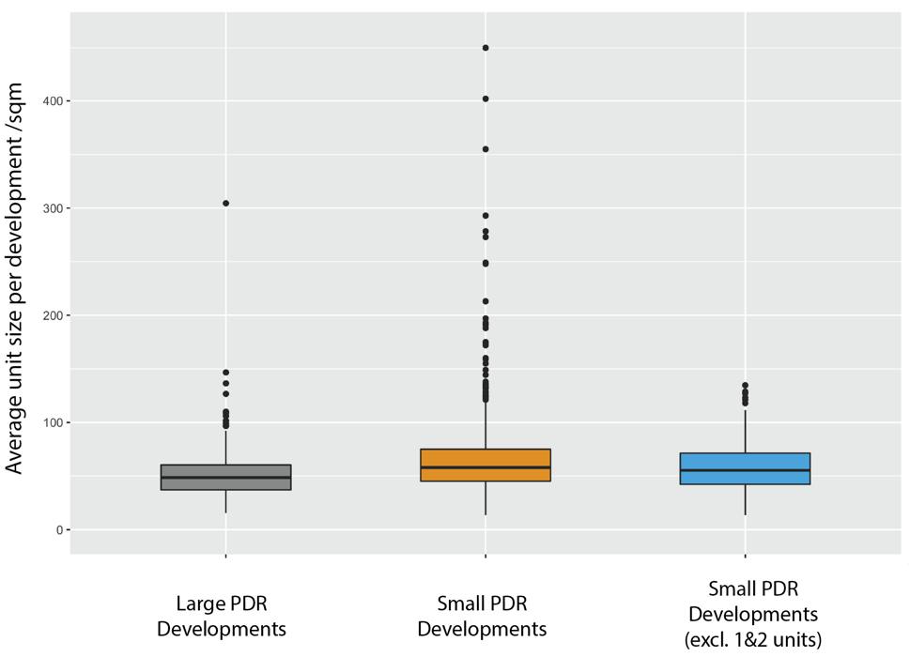

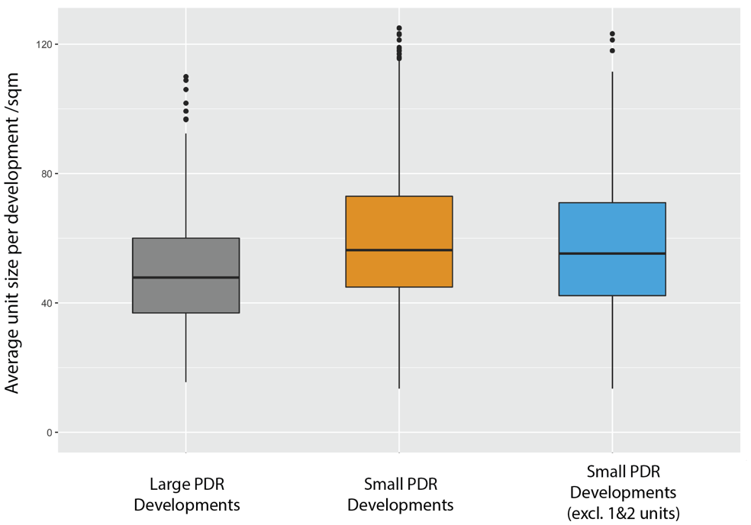

Figure 5.8: Box and whisker plot showing the distribution of average unit size for large and small PDR developments. Additional image on the bottom provides close-up view of the boxplot.

With a median size of 58sqm and mean of 65.6sqm, flats delivered by small PDR developments were considerably bigger than flats of large PDR developments (median: 48.6sqm; mean: 53.4sqm) (Figure 5.8). To investigate if large, 1-unit PDR conversions were skewing the overall data for small PDR developments, a separate plot considering developments between 3-10 units. Here, the median and mean values dropped slightly to 55.3sqm and 57.9sqm respectively, but still remained larger than units delivered by large PDR developments.

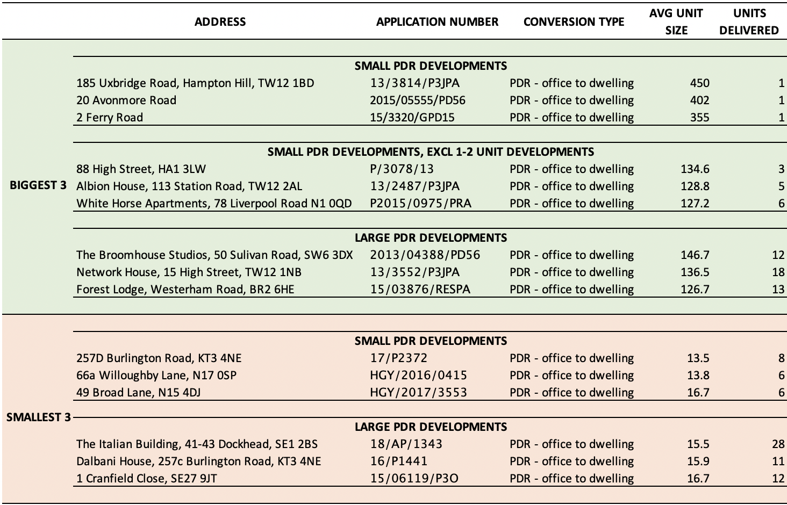

Table 5.2: Top and bottom 3 small and large PDR developments, by average unit sizes

Table 5.2 highlights that the PDR conversion policy has been used to create some large single-family homes, as seen in 185 Uxbridge Road, where offices were converted into a 4-bedroom single-family home (Appendix 1).

Looking at the biggest units, a variety of luxury apartments have been delivered, both by small and large PDR developments. For instance, the Broomhouse Studios has produced 10 two-bedroom and 2 three-bedroom flats (Figure 5.9; Appendix 2), with a two-bedroom unit being sold for £2,850,000 in November 2021 - hardly an affordable price, given that the local MSOA had a median price paid of £755,000 for Q4 2021 (ONS, 2022).

For developments with the smallest average unit size, both large and small PDR developments are guilty of producing micro flats way below the nationally described space standard of 37sqm. The smallest of which, 257D Burlington Road, consist of 8 studio units of 13 - 14sqm (Figure 5.10; Appendix 3). Layouts such as the one observed in Burlington Road have been well documented by existing literature.

Lastly, it seems that the biggest culprits of small units are not mega developments delivering upwards of 100 units, but those delivering between 5 and 30 units. These developments might be able to more easily fly under the radar of academics and the media, as compared to the conversion of large office blocks that are easier to spot and attract scrutiny.



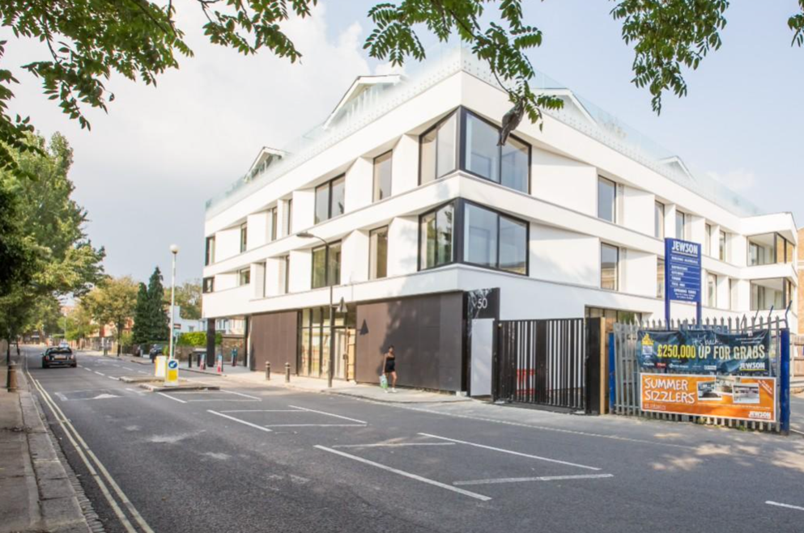

Figure 5.9: A luxury 2-bedroom unit in the Broomhouse Studios development

(Rightmove, 2022)



Figure 5.10: Layout of the 8 studio units that are part of the 257D Burlington Road development (LB Merton, 2017)

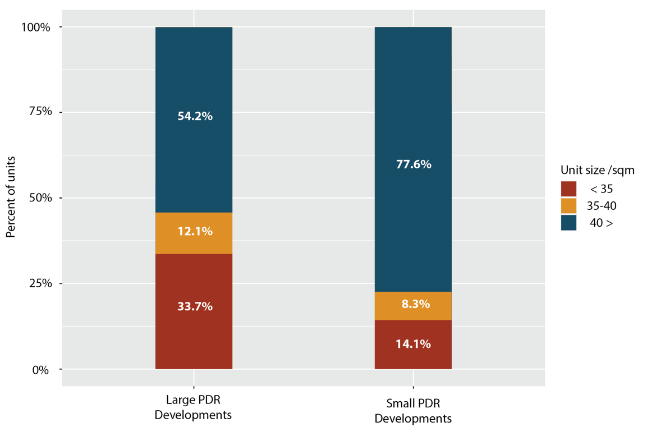

Figure 5.11: Stacked bar-chart showing the proportion of units flouting the nationally prescribed space standards (35sqm) delivered by small and large PDR developments

From Figure 5.11, large PDR developments (33.7%) have delivered a greater number of units smaller than the nationally described space standard, compared to small PDR developments (14.1%). There also seems to be a significant number of units around 35-40sqm, indicating that developers might have done the minimum to meet these standards. Whilst 33.7% and 14.1% of small and large PDR flats flouting the nationally described space standards may seem like a high number, the values here are significantly lower than the 86.4% figure Clifford et al (2019) and 70% figure Ferm et al (2020) found in their case studies.

Unfortunately, there is insufficient data post April 2021, making it difficult to analyse whether adding the nationally described space standards as part of the prior approval conditions helped ensure most PDR developments complied with the space standards.

# DISCUSSION

## Implications & Next Steps

While the distribution of large PDR developments exhibited a pattern that has been generally well studied by existing literature, the distribution of small PDR developments has provided new insight into this sub-category of PDR conversions.

For one, the large cluster of small PDRs developments in southwest London is surprising, and has garnered little attention thus far. Existing literature has mainly focused on Croydon and other central London boroughs such as Islington and Camden (EGi, 2015; Ferm et al, 2020), somewhat neglecting the boroughs of Hammersmith & Fulham, Richmond, Merton and Wandsworth. The finding in this dissertation warrant in-depth studies into how these boroughs are managing small PDR developments, and on-the-ground opinion regarding these new developments. If found to be managed well, the practices of these boroughs could be a precedent for inner London boroughs like Westminster who have opted instead to apply blanket Article 4 directions to ban PDR conversions. If done properly, PDR developments could be a beneficial way to create infill developments in areas that are experiencing high demand but have limited land on which to deliver new housing.

Secondly, the elongated clustering of small PDR developments following certain busy roads seen on the KDE map might be a cause for concern. Clusters of small PDR developments trailing the A1000 Great N Road and A21 London/Bromley Road indicate the conversion of many office, retail and restaurants to residential uses. These roads comprise many important high streets such as Lewisham, Catford, Bromley and East Finchley, potentially contributing to their demise (Hughes & Jackson, 2015; Carmona, 2015). The existence of such clusters also supports Clifford, Dennett and Chi’s (2021) concerns regarding the expansion of PDR to Class E uses, enabling amenities and recreational facilities along high streets to be converted to residential uses. This serves as a warning sign on what might follow for London’s already struggling high streets, given the ease of conversions brought about by the new PDR expansion. Moving forward, detailed road studies along the A1000 and A21 corridors could be conducted, to explore the impact PDR policies have on local high streets.

In studying the correlation between PDR clusters and socio-demographic factors, the data demonstrates why small PDR developments should not be overlooked. Despite having no observable trends for large PDR developments, clusters of small PDR developments exhibited positive correlations with median house prices and percentage of small households. In comparison to large PDR developments, which tend to focus on the conversion of large office blocks that are concentrated in London’s town centres, developers of small PDR developments have more flexibility to select strategic locations that could yield higher economic returns, which explains the aforementioned trends.

The positive correlation between clusters of small PDR developments and the percentage of small households within neighbouring MSOAs supports Ferm et al’s (2020:10) finding that the PDR policy is “facilitating new niche products to come to the market” targeting students and young professionals. Furthermore, the positive correlation between small PDR developments and the median house prices of surrounding MSOA tracts indicate that developers are naturally more willing to undertake PDR conversion projects in areas with high median house prices. Both the high percentage of small households and high median house prices experienced in southwest London MSOAs give potential insights on the observed clustering of small PDR developments in these exact areas.

Going forward, these attributes could be used as indicators for local authorities to identify areas at-risk of losing their commercial and business vitality, in addition to being incorporated into the decision-making rubric when local authorities intend to gazette a new area under Article 4 directions. Additional potential correlation with other socio-demographic factors such as student population, availability of office stock and housing demand could also be tested to make the indicators more comprehensive.

The analysis of locational attributes for both small and large PDR developments supported Clifford et al’s (2019) and Ferm et al’s (2020) case study research that found that PDR developments are generally well located, but a significant number of them are located alongside busy and polluted roads. The ease of access to train stations for these developments (98% and 95% of small and large PDR developments respectively within a 1500m walk to the nearest station) highlights a success of the PDR policy, in creating new homes that are well connected.

Nonetheless, an issue of concern would be the number of developments experiencing high rates of NO2 pollution - 78% of small and 72% of large PDR developments are located in the upper quartile of the most heavily NO2 polluted areas in London - possibly due to their proximity to busy roads. This calls for strengthened pollution and noise standards in future PDR developments to ensure the wellbeing of its inhabitants (WHO, 2013). For instance, prior approval conditions could be expanded to include stricter noise impact requirements for PDR developments that are located immediately adjacent to busy roads, requiring triple glazed windows to reduce indoor ambient noise levels. Moreover, air pollution mitigation requirements should be included as part of prior approval conditions, such as enforcing in-built air filters to reduce ambient indoor pollution levels.

For quality analysis, results on energy rating and glazing were generally similar for small and large PDR developments. While PDR developments created dwellings that had better ratings (C) than the average London home (D), they underperformed compared to newly-built dwellings (B). While a tiny amount, 56 (1.2%) PDR units had the worst energy ratings of F and G, indicating little was done to upgrade the building’s quality post-conversion. Clifford et al (2019) had earlier flagged such cases, where developers for Newbury House did “the absolute minimum” to convert the office block to residential use, with the building being “in general poor conditions, particularly the windows”. Given how “energy-efficiency attributes are contingent on the architectural quality of homes” (Marmolejo-Duarte and Chen, 2022:1), the quality of PDR developments could be improved by requiring developers to improve the energy rating of buildings below C by 1 or 2 grades, as part of the conditions for prior approval.

The limited data surrounding glazing indicated that most units are double-glazed, which should be theoretically sufficient to reduce traffic noise and provide adequate insulation. That said, the type of infill gas and thickness of glass are important factors influencing the quality of insulation, which current EPC data lacks (Arici & Karabay, 2010).

Analysis on average development unit size found a range of big units and tiny units being delivered by both small and large PDR developments, with small PDR developments delivering larger average unit sizes. Nonetheless, both small and large PDR developments have delivered units at both ends of the scale - micro units that are smaller than the nationally described space standards and large, luxury units that are far above the local MSOA’s median house price. The percentage of small and large PDR flats flouting minimum space standards were also much lower than the figures obtained by Clifford et al (2019) and Ferm et al (2020) in their case studies.

The data produced by no means gives a complete overview of the size of all PDR developments within London, but it enables developments that have produced the smallest units to be identified. Delivering between 5 and 30 units, these developments are small enough to avoid public and media scrutiny, despite providing flats as small as 13.5sqm, as compared to large office block conversions that have attracted more intense scrutiny (Wainwright, 2020). Moreover, attempts to account for most PDR developments in London demonstrated that the issue of PDR flats flouting minimum space standards is less serious than what case studies have shown.

The novelty of joining EPC data with prior approval datasets to assess the associated quality and size attributes of PDR developments will gain increased importance, especially with the introduction of Class E to residential PDRs that will see more small-sized conversions of retail and amenity spaces taking place. These conversions will likely be harder to spot (compared to a prominent large office block), requiring researchers to either trawl through thousands of prior approvals manually, or use such qualitative studies as a starting point for in-depth research. Subsequently, more research could be done in increasing the match rate, and potentially joining land registry price-paid data to give an even more comprehensive overview of individual PDR developments. Obtaining price-paid data of PDR developments through this means can open up research on the affordability of these developments, by comparing them with developments delivered through planning applications on a per square-foot basis. Lastly, besides its applicability of studying PDR developments beyond London in cities facing similar developmental pressure such as Manchester and Birmingham, this study sets a precedence in the use of quantitative spatial analyses in the English planning system.

## Additional Inputs on Regulation and Covid-19

While some might claim that expanding prior approval conditions to include energy ratings, glazing and in-built air filters goes against the light-touch, laissez-faire approach of PDR policies that aims to encourage housing deliveries, it is undeniable that a large proportion of PDR developments are exposed to unacceptable levels of pollution and a number of developers are putting in the bare minimum for PDR conversions. As Maddedu, Gallent & Mace (2015) find, there exists a balance where policies fulfil the moral imperative of guaranteeing a basic decency in new homes, while being flexible enough to encourage creative solutions. Expanding prior-approval conditions to solve the most pertinent issues plaguing PDR developments therefore seems reasonable, and follows the precedent set when minimum space standards were added to the prior approval conditions in April 2021 after studies (Clifford et al, 2018) found a large number of PDR developments delivering micro units that were unsuitable for habitation.

The case for expanding minimum standards has also been heightened post Covid-19, as people spend more time at home following new flexible and home-working arrangements. The findings in this paper, coupled with proposed recommendations echo that of Madeddu & Clifford (2021) highlighting the urgency of introducing new regulation, to prevent the costs of poor PDR design being borne by the occupants alone. As they summarised, “liveability in housing cannot be sacrificed in pursuit of a delivery target and that ‘home’ has to deliver against health, wellbeing and social equity goals” (ibid:4).

## Limitations

A large limitation within this study revolves around the datasets used. While special attention was put to remove duplicate and irrelevant entries from the prior approvals dataset, some data were found to be incorrectly recorded with erroneous postcodes. Some postcodes were also changed during the development process, to cope with the increased number of units on a site. Additionally, the study assumed that all PDR conversions were meant for long-term dwelling, failing to account for the possibility of PDR-created dwellings being converted subsequently to other uses such as hotels and student accommodations. This meant that there may be some overcounting involved regarding the number of PDR dwellings reflected in the Prior Approvals Dataset.

Erroneous data input, new postcodes, the different ways that addresses were recorded across different datasets and rebranded building names made it impossible to get a perfect match between EPC data and prior approvals data, resulting in probabilistic matches instead. This means that the size and quality attributes analysed are based on best estimates that are designed to give an idea of PDR trends within London, but not the full picture.

When some of the data was cross checked with planning applications records online, it was found that the average unit sizes of certain developments differed greatly from the plans submitted in planning applications. This was a consequence of being unable to pull out the EPC certificates for all units within a development and also instances where the recorded size of a flat was assumed to be an entire floorspace, even though only a portion of said space was converted from office to residential uses. The issues identified here were most prominent for 1 to 2-unit PDR developments. Though a logical solution to this would be to exclude small PDR developments, as other studies have done (EGi, 2015), doing so would result in missing prominent patterns as our results have earlier shown. Alas, this highlights the importance of standardising data input format across various datasets. Future research could also focus on increasing the match rate for the EPC-prior approval join.

The use of EPC data has drawbacks too. Hardy & Glew (2019) find that 27% of EPC records are incorrect, while estimating the true error rate to be between 36% and 62%. These errors range from duplicates which are easily rectifiable, to discrepancies in property floor areas and energy ratings that have an impact on the results of this study (ibid.).

Furthermore, the different publishing dates of secondary data used in this research might not make for fair comparison. The inconsistency of dates means that information from different timescales were being compared, potentially affecting the final results.

Besides data, aggregating PDR developments into MSOA tracts for spatial analysis conjures the issue of the Modifiable Areal Unit Problem, where data aggregated into different spatial scales will provide different results (Wong, 2009). While MSOA was chosen as a compromise to preserve granularity yet keep trends general enough to be observed on a London-wide scale, Lloyd (2016) notes that it is not geographically detailed enough to ensure meaningful analysis of local-level differences between places. Additionally, the aggregation of PDR development into MSOAs masked certain trends that were highlighted by the KDE.

# CONCLUSION

To conclude, this research attempted to answer the question of

*“How has the change-of-use Permitted Development Right (PDR) policy influenced the location and type of housing delivered through this scheme in London?”*

by investigating the spatial extent and distribution of PDR developments in London, before analysing their locational, size and quality attributes.

Through quantitatively analysing all the PDR developments recorded on the prior approvals dataset, the research verified trends described by existing qualitative research in the study of PDR developments. These include the high exposure of PDR developments to vehicular-related NO2 pollution, their ease of access to public transport, the clustering of PDRs across London’s regional centres and the issue of micro apartments being delivered by the scheme.

What was more interesting, however, related to a sub-category of PDR developments that did not receive much attention from existing literature - small PDR developments that delivered 10 or fewer units. The results for this sub-category of PDR developments were notably different from what is currently understood by existing literature. The clustering of these developments in southwest London and along busy arterial roads across the capital, positive correlation with median house prices and percentage of small households and relatively larger median house size compared to large PDR developments were of particular interest.

These are important patterns as the prominence of small PDR developments is predicted to rise, given that new Class E to residential conversions allows restaurants, cafes and amenity space to be converted. These spaces are usually small, likely delivering 10 units or less.

Alas, the strategy of using quantitative methods to study PDR developments will be even more crucial, as these small developments are less easy to spot and low-quality developments can easily fly under the radar. Using quantitative research can therefore be a starting point to identify problematic areas, spatial trends or developments that are of very poor quality for further in-depth quantitative or qualitative research. This also highlights the importance of adopting such quantitative spatial analysis on wider planning research, a field that is dominated mainly with qualitative research.

The results of this study have informed avenues of future potential studies surrounding PDRs, including

1. In-depth studies on how southwest London boroughs like Hammersmith & Fulham, Richmond, Merton and Wandsworth are managing the cluster of small PDR developments in their area
2. Detailed road studies along the A1000 and A21 road corridors regarding the impact of small PDR developments on high street vitality and the loss of active frontages

Policy wise, the study recommends

1. Incorporating socio-economic indicators such as median house price and percentage of small households to identify areas at-risk of intense PDR developments
2. Strengthening pollution protections by incorporating triple-glazing requirements and air-filtration systems as part of the prior approvals process for developments most affected by vehicular pollution
3. Ensuring effort is put into building refurbishment and quality by, requiring developers to improve the energy rating of buildings below grade C by 1 or 2 grades as part of the conditions for prior approval

This study comes at a time when PDR policies are being rapidly expanded as part of the government’s attempt to solve the housing crisis by boosting housing supply from developers. While the policy has increased home deliveries, the laissez-faire approach of this policy has led to a myriad of problems, ranging from pollution exposure, small unit sizes and poor quality.

Occurring in parallel to the housing crisis, the importance of quality homes has been of increased importance, given how flexible and homeworking arrangements post Covid-19 increased the amount of time people spent at home.

Therefore, a balance needs to be struck where PDR policies remain flexible enough to promote housing deliveries, while bad quality homes are minimised with basic regulations in place. To quote Madeddu and Clifford (2021:4), “planning control can offer safeguards against extremes of poor quality whilst still allowing some flexibility for good design”.

# REFERENCES

Anselin, L., 1995. Local indicators of Spatial Association-Lisa. *Geographical Analysis*, 27(2), pp.93–115.

Arıcı, M. & Karabay, H., 2010. Determination of optimum thickness of double-glazed windows for the climatic regions of Turkey. *Energy and Buildings*, 42(10), pp.1773–1778.

Baddeley, A. & Rubak, E., 2017. *Advanced R course on spatial point patterns.* Online. Available at: https://spatstat.org/SSAI2017/slides/slides.pdf [Accessed July 16, 2022].

Baker, S. & Parker, G., 2018. Permitted development rights liberalisation in rural England: labour’s lost love? *Town and Country Planning*, 87(3). pp.117-123.

Barrett, J., 2018. Vacant Property Taxes and the Human Right to Adequate Housing. *Journal of Australian Taxation*, 20(5), pp.123–146.

Bell, C., 2022. *London Stations.* Online. Available at: https://www.doogal.co.uk/london_stations [Accessed July 17, 2022].

Bensted, S., 2021. A one-size-fits-all approach will not save our highstreets. *British Property Foundation*. Available at: https://bpf.org.uk/media/blogs/a-one-size-fits-all-approach-will-not-save-our-highstreets/ [Accessed August 1, 2022].

Bibby, P., Brindley, P., Dunning, R., Henneberry, J., McClean, A. and Tubridy, D., 2018. *The Exercise of Permitted Development Rights in England Since 2010,* Report to the RICS Research Trust, RICS, London.

Boardman, B., 2007. Examining the carbon agenda via the 40% house scenario. *Building Research & Information*, 35(4), pp.363–378.

Booth, P., 2003. *Planning by consent: The origins and nature of British Development Control*, London: Routledge.

Buyuklieva, B., 2022. *London’s Demographic Metabolism: Using Computational Social Science Methods to Map Mobility in Populations and Places.* PhD thesis, University College London, London.

Carmona, M., 2015. London's Local High Streets: The problems, potential and complexities of mixed street corridors. *Progress in Planning*, 100, pp.1–84.

CentrePiece, 2014. *What lies behind Britain’s crisis of housing affordability?* Available at: https://cep.lse.ac.uk/pubs/download/cp421.pdf

Cheshire, P., 2009. *Urban Containment, Housing Affordability and Price Stability - Irreconcilable Goals.* Available at: https://eprints.lse.ac.uk/59240/1/__lse.ac.uk_storage_LIBRARY_Secondary_libfile_shared_repository_Content_LSE%20Spatial%20Economic%20Research%20Centre_SUNAINA%20SERC_sercpp004.pdf

Clifford, B., Ferm, F., Livingstone, N., Canelas, P., 2018. Assessing the Impacts of Extending Permitted Development Rights to Office-to- Residential Change of Use in England, Report to the RICS Research Trust, RICS, London.

Clifford, Ben., Timmer, M., Zhu, Y. & Ferm, J., 2019. *Healthy Homes? Thirty Examples of Permitted Development Conversions.* Online. Available at: https://discovery.ucl.ac.uk/id/eprint/10088243/1/TCPA%20Room%20the%20Breathe%20Examples%20-%20Clifford%20et%20al.pdf

Clifford, Ben., Dennett, A. & Chi, B., 2021. *Mapping Class E: Understanding the expansion of permitted development.* Online. Available at: https://tcpa.formandfunction.dev/wp-content/uploads/2021/11/mappingclassereport-uclv3_ss.pdf

Colenutt, B., 2020. Financing Housing Investment. *The Property Lobby*, pp.47–56.

Collinson, P., 2014. What the distance from the station does to the price of your House. *The Guardian*. Available at: https://www.theguardian.com/money/2014/aug/20/distance-from-station-value-of-house-nationwide-uk [Accessed August 16, 2022].

Coppalle, A., Delmas, V. & Bobbia, M., 2001. Variability of nox and NO2 concentrations observed at pedestrian level in the city centre of a medium sized urban area. *Atmospheric Environment*, 35(31), pp.5361–5369.

DCLG (Department for Communities and Local Government)., 2012. *New opportunities for sustainable development and growth through the reuse of existing buildings - consultation.* Online. Available at: https://assets.publishing.service.gov.uk/government/uploads/system/uploads/attachment_data/file/8351/2171937.pdf

Derbyshire, M. & Havers, T., 2014. Office-to-residential conversions under permitteddevelopment: De-regularising the planning system. *Journal of Building Survey, Appraisal & Valuation,* 3(4), pp.311-316.

Dubé, J., Thériault, M. & Des Rosiers, F., 2013. Commuter Rail Accessibility and house values: The case of the Montreal South Shore, Canada, 1992–2009. *Transportation Research Part A: Policy and Practice*, 54, pp.49–66.

EC (European Commission). 2018. *Ethics and Data Protection.* Online. Available at: https:ec.europa.eu/info/sites/default/files/5._h2020_ethics_and_data_protection_0.pdf [Accessed August 1, 2022].

Edwards, M., 2016. The Housing Crisis and London. *City*, 20(2), pp.222–237.

EGi London Residential Research, 2014. Office to Residential – Changes in Permitted Development Rights – Part 1. London: EGi.

EGi London Residential Research, 2015. *Office to Residential – Changes in Permitted Development Rights – Part 3.* London: EGi.

Evans, J., 2018. 'slums of the future'? UK office-to-homes policy sparks fears. *Subscribe to read | Financial Times*. Available at: https://www.ft.com/content/48fbe55c-ffb2-11e8-ac00-57a2a826423e [Accessed August 15, 2022].

Ferm, J. et al., 2020. Emerging problematics of deregulating the urban: The case of permitted development in england. *Urban Studies*, 58(10), pp.2040–2058.

Galarnyk, M., 2020. Understanding Boxplots. *Medium*. Available at: https://towardsdatascience.com/understanding-boxplots-5e2df7bcbd51 [Accessed August 15, 2022].

Gallego-Valadés, A., Ródenas-Rigla, F. & Garcés-Ferrer, J., 2021. Spatial distribution of public housing and urban socio-spatial inequalities: An exploratory analysis of the valencia case. *Sustainability*, 13(20), p.11381.

Gallent, N., Madeddu, M. & Mace, A., 2010. Internal Housing Space Standards in Italy and England. *Progress in Planning*, 74(1), pp.1–52.

Gallent, N., Durrant, D. & May, N., 2017. Housing Supply, investment demand and money creation: A comment on the drivers of London’s housing crisis. *Urban Studies*, 54(10), pp.2204–2216.

Gatrell, A.C. et al., 1996. Spatial Point Pattern Analysis and its application in geographical epidemiology. *Transactions of the Institute of British Geographers*, 21(1), p.256.

Getis, A. & Ord, J.K., 1992. The analysis of Spatial Association by use of Distance Statistics. *Geographical Analysis*, 24(3), pp.189–206.

Grimwood, G., 2021. *Planning in England: permitted development and change of use - Briefing Paper.* Online. Available at: https://researchbriefings.files.parliament.uk/documents/SN00485/SN00485.pdf

Hamann, U. & Türkmen, C., 2020. Communities of Struggle: The making of a protest movement around housing, migration and racism beyond identity politics in Berlin. *Territory, Politics, Governance*, 8(4), pp.515–531.

Hardy, A. & Glew, D., 2019. An analysis of errors in the Energy Performance Certificate Database. *Energy Policy*, 129, pp.1168–1178.

Harlander, T., 2018. Wohnungspolitik [Building Politics]. In *Handwörterbuch der stadt und raumentwicklung*. Hannover: ARL - Akademie für Raumforschung und Landesplanung, pp. 2953–2965.

Hilber, C.A. & Vermeulen, W., 2012. The impact of supply constraints on house prices in England. *SSRN Electronic Journal*.

Hubbard, P., Reades, J. & Walter, H., 2021. Housing: Shrinking homes, covid-19 and the challenge of homeworking. *Town Planning Review: Volume 92, Issue 1*, 92(1), pp.3–10.

Hughes, C. & Jackson, C., 2015. Death of the high street: Identification, prevention, reinvention. *Regional Studies, Regional Science*, 2(1), pp.237–256.

Jenks, G.F. & Caspall, F.C., 1971. Error On Choroplethic Maps: Definition, Measurement, Reduction. *Annals of the Association of American Geographers*, 61(2), pp.217–244.

Jones, R., 2021. Converting shops to flats 'could lead to low-quality homes'. *The Guardian*. Available at: https://www.theguardian.com/money/2021/may/15/converting-shops-to-flats-could-lead-to-low-quality-homes [Accessed August 15, 2022].

Kim, K., Garcia, I. & Brewer, S., 2021. Spatial relationship between eviction filings, neighborhood characteristics, and proximity to the Central Business District: A case study of salt lake county, Utah. *Housing Policy Debate*, 31(3-5), pp.601–626.

King, T.L. et al., 2016. Using kernel density estimation to understand the influence of neighbourhood destinations on BMI. *BMJ Open*, 6(2), pp.1–8.

Krisp, J.M. et al., 2009. Visual bandwidth selection for kernel density maps. *Photogrammetrie - Fernerkundung - Geoinformation*, 2009(5), pp.445–454.

LB Richmond, 2013. Planning application number: 13/3814/P3JPA. *Planning detail - London Borough of Richmond upon Thames*. Available at: https://www2.richmond.gov.uk/lbrplanning/Planning_CASENO.aspx?strCASENO=13%2F3814%2FP3JPA&DocTypeID=41#docs [Accessed August 20, 2022].

LBHF, 2013. Planning – planning application documents for 2013/04388/PD56. *2013/04388/PD56 | Change of use of first and second floor levels from offices (Class B1) into 10 x two bedroom and 2 x three bedroom self contained units (Class C3) | 50 Sulivan Road London SW6 3DX*. Available at: https://public-access.lbhf.gov.uk/online-applications/applicationDetails.do?activeTab=documents&keyVal=MURDHKBI0UJ00 [Accessed August 20, 2022].

LB Merton, 2017. Documents associated with Planning Application, Reference ID: 17/P2372. *Planning Explorer.* Available at: https://planning.merton.gov.uk/MVM/Online/DMS/DocumentViewer.aspx?pk=1000098765&SearchType=Planning%20Application [Accessed August 20, 2022]

Lewis, B., 2015. Thousands more homes to be developed in planning shake up. *GOV.UK*. Available at: https://www.gov.uk/government/news/thousands-more-homes-to-be-developed-in-planning-shake-up [Accessed May 17, 2022].

Lichfield, N., 2003. *Review of Permitted Development Rights.* Online. Available at: https://planningjungle.com/wp-content/uploads/Review-of-Permitted-Development-Rights-September-2003.pdf

Lichfields., 2021. *Guide to the Use Classes Order in England (from 1 August 2021).* Online. Available at: https://lichfields.uk/media/7156/guide-to-the-use-classes-order-in-england.pdf [Accessed July 22, 2022].

Lloyd, C.D., 2016. Spatial scale and small area population statistics for England and Wales. *International Journal of Geographical Information Science*, 30(6), pp.1187–1206.

LondonCouncils., 2015. *The Impact of Permitted Development Rights for Office to Residential Conversions - a London Councils briefing.* Online. Available at: https://www.londoncouncils.gov.uk/download/file/fid/16326 [Accessed July 21, 2022].

London Datastore., 2011. *Statistical GIS Boundary Files for London.* Online. Available at: https://data.london.gov.uk/dataset/statistical-gis-boundary-files-london [Accessed July 17, 2022].

London Datastore., 2014. *MSOA Atlas.* Online. Available at: https://data.london.gov.uk/dataset/msoa-atlas [Accessed July 17, 2022].

London Datastore., 2021. *Datahub prior approvals analysis December 2021.* Online. Available at: https://data.london.gov.uk/dataset/datahub-prior-approvals-analysis-december-2021 [Accessed July 17, 2022].

Longley, P. et al., 2016. *Geographic information science and systems*, Hoboken, NJ: Wiley Custom Learning Solutions.

Lord, A. & Tewdwr-Jones, M., 2012. Is planning “under attack”? Chronicling the deregulation of urban and Environmental Planning in England. *European Planning Studies*, 22(2), pp.345–361.

Lovelace, R., Nowosad, J. & Muenchow, J., 2022. Chapter 4 Spatial Data Operations: Geocomputation with R. *Chapter 4 Spatial data operations | Geocomputation with R*. Available at: https://geocompr.robinlovelace.net/spatial-operations.html [Accessed August 15, 2022].

Maantay, J., 2007. Asthma and air pollution in the Bronx: Methodological and data considerations in using GIS for Environmental Justice and health research. *Health & Place*, 13(1), pp.32–56.

Madeddu, M. & Clifford, B., 2021. Housing Quality, permitted development and the role of regulation after covid-19. *Town Planning Review: Volume 92, Issue 1*, 92(1), pp.41–48.

Madeddu, M., Gallent, N. & Mace, A., 2015. Space in new homes: Delivering functionality and liveability through regulation or Design Innovation? *Town Planning Review*, 86(1), pp.73–95.

Malpass, P., 2021. *The Housing Crisis* 1st ed., London: Routledge.

Marmolejo-Duarte, C. & Chen, A., 2022. The effect of energy performance ratings over residential prices or how an insufficient control of architectural-quality may render spurious conclusions. *Cities*, 126, pp.1–15.

Marsh, R., Chang, M. & Wood, J., 2020. The relationship between housing created through permitted development rights and Health: A Systematic Review. *Cities & Health*, pp.1–20.

McHugh, M.L., 2013. The chi-square test of Independence. *Biochemia Medica*, pp.143–149.

Mercer, S., Harlow Homes: How PDR destroys local communities and builds Britain's worst housing. *The Developer*. Available at: https://thedeveloper.live/film/film/harlow-homes-how-pdr-destroys-local-communities-and-builds-britains-worst-housing [Accessed August 15, 2022].

MHCLG (Ministry of Housing, Communities & Local Government), 2020. *Planning for the Future: White Paper August 2020.* Online. Available at: https://assets.publishing.service.gov.uk/government/uploads/system/uploads/attachment_data/file/958420/MHCLG-Planning-Consultation.pdf

MHCLG (Ministry of Housing, Communities & Local Government)., 2021. *National Planning Policy Framework.* Online. Available at: https://assets.publishing.service.gov.uk/government/uploads/system/uploads/attachment_data/file/1005759/NPPF_July_2021.pdf

Moran, P.A., 1948. The interpretation of Statistical Maps. *Journal of the Royal Statistical Society: Series B (Methodological)*, 10(2), pp.243–251.

Muldoon-Smith, K. & Greenhalgh, P., 2016. Greasing the wheels, or a spanner in the works? permitting the adaptive re-use of redundant office buildings into residential use in England. *Planning Theory & Practice*, 17(2), pp.175–191.

ONS (Office for National Statistics), 2021. Energy efficiency of housing in England and Wales: 2021. *Energy efficiency of housing in England and Wales - Office for National Statistics*. Available at: https://www.ons.gov.uk/peoplepopulationandcommunity/housing/articles/energyefficiencyofhousinginenglandandwales/2021 [Accessed August 16, 2022].

Ord, J.K. & Getis, A., 1995. Local spatial autocorrelation statistics: Distributional issues and an application. *Geographical Analysis*, 27(4), pp.286–306.

PlanningPortal, 2021. Content updates: New minimum space standards, April 2021. *Planning Portal Blog*. Available at: https://blog.planningportal.co.uk/2021/03/30/content-updates-new-minimum-space-standards-april-2021/ [Accessed August 15, 2022].

Rae, A., 2020. Hey, what's an MSOA? *Stats, Maps n Pix*. Available at: http://www.statsmapsnpix.com/2020/10/hey-whats-msoa.html [Accessed August 18, 2022].

Rey, S., Arribas-Bel, D. & Wolf, L., 2020. Geographic Data Science with python. *Local Spatial Autocorrelation - Geographic Data Science with Python*. Available at: https://geographicdata.science/book/notebooks/07_local_autocorrelation.html [Accessed August 15, 2022].

RICS (Royal Institute of Chartered Surveyors)., 2018. *Extending permitted development rights in England: the implications for public authorities and communities.* Online. Available at: https://www.rics.org/en-za/news-insight/research/insights/extending-permitted-development-rights-in-england-the-implications-for-public-authorities-and-communities/

Rightmove, 2022. Check out this 2 bedroom flat for rent on Rightmove. *Rightmove.co.uk*. Available at: https://www.rightmove.co.uk/properties/125860718#/?channel=RES_LET [Accessed August 20, 2022].

Romão, J., Guerreiro, J. & Rodrigues, P.M., 2017. Territory and Sustainable Tourism Development: A space-time analysis on European regions. *REGION*, 4(3), pp.1–17.

Sassen, S., 2005. The Global City: Introducing a Concept. *Brown Journal of World Affairs*, 11(2), pp.27–43.

Schipper, S., 2021. Der Staat Als Adressat Städtischer Sozialer Bewegungen. Wohnungspolitische Kämpfe und Postneoliberale Konstellationen [The State as an Addressee of Urban Social Movements. Housing Struggles and Post-Neoliberal Constellations]. *Zeitschrift für Wirtschaftsgeographie*, 45(2), pp.58–71.

Sudalma, S., Purwanto, P. & Santoso, L.W., 2015. The effect of SO2 and NO2 from transportation and stationary emissions sources to SO42− and NO3− in rain water in Semarang. *Procedia Environmental Sciences*, 23, pp.247–252.

Town and Country Planning (General Permitted Development) (England) Order 2015 (SI 2015/596). Available at: https://www.legislation.gov.uk/uksi/2015/596/schedule/2/made [Accessed August 11, 2022].

Vollmer, L. & Kadi, J., 2018. Wohnungspolitik in der Krise des neoliberalismus in Berlin und Wien [Housing policy in the crisis of neoliberalism in Berlin and Vienna]. *PROKLA. Zeitschrift für kritische Sozialwissenschaft*, 48(191), pp.247–264.

Wainwright, O., 2020. Our slum future: The planning shakeup set to blight English housing. *The Guardian*. Available at: https://www.theguardian.com/artanddesign/2020/jul/24/our-slum-future-the-planning-shakeup-set-to-blight-british-housing [Accessed August 15, 2022].

Wetzstein, S., 2017. The Global Urban Housing Affordability Crisis. *Urban Studies*, 54(14), pp.3159–3177.

Wetzstein, S., 2019. Comparative Housing, Urban Crisis and political economy: An ethnographically based ‘long view’ from Auckland, Singapore and Berlin. *Housing Studies*, 34(2), pp.272–297.

WHO (World Health Organisation). 2013. *Review of evidence on health aspects of air pollution - REVIHAAP Project.* Online. Available at:https://www.ncbi.nlm.nih.gov/books/NBK361805/pdf/Bookshelf_NBK361805.pdf [Accessed 1 August, 2022].

Wong, D.W., 2009. Modifiable Areal Unit Problem. *International Encyclopedia of Human Geography*, pp.169–174.

Wyly, E. & DeFilippis, J., 2010. Mapping public housing: The case of New York City. *City & Community*, 9(1), pp.61–86.

Zhang, Z. et al., 2013. Using GIS and KDE Analysis Spatial Distribution on public housing households: A case study. *2013 8th International Conference on Computer Science & Education*, pp.925–930.

# APPENDIX

## Appendix 1: Planning Documents for 185 Uxbridge Road (LB Richmond, 2013)

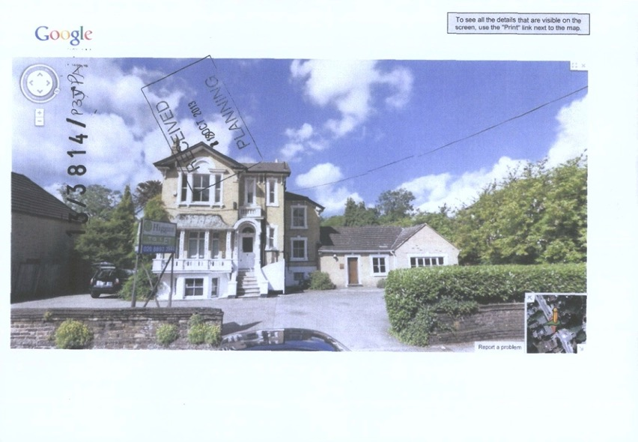

*Site Photo*

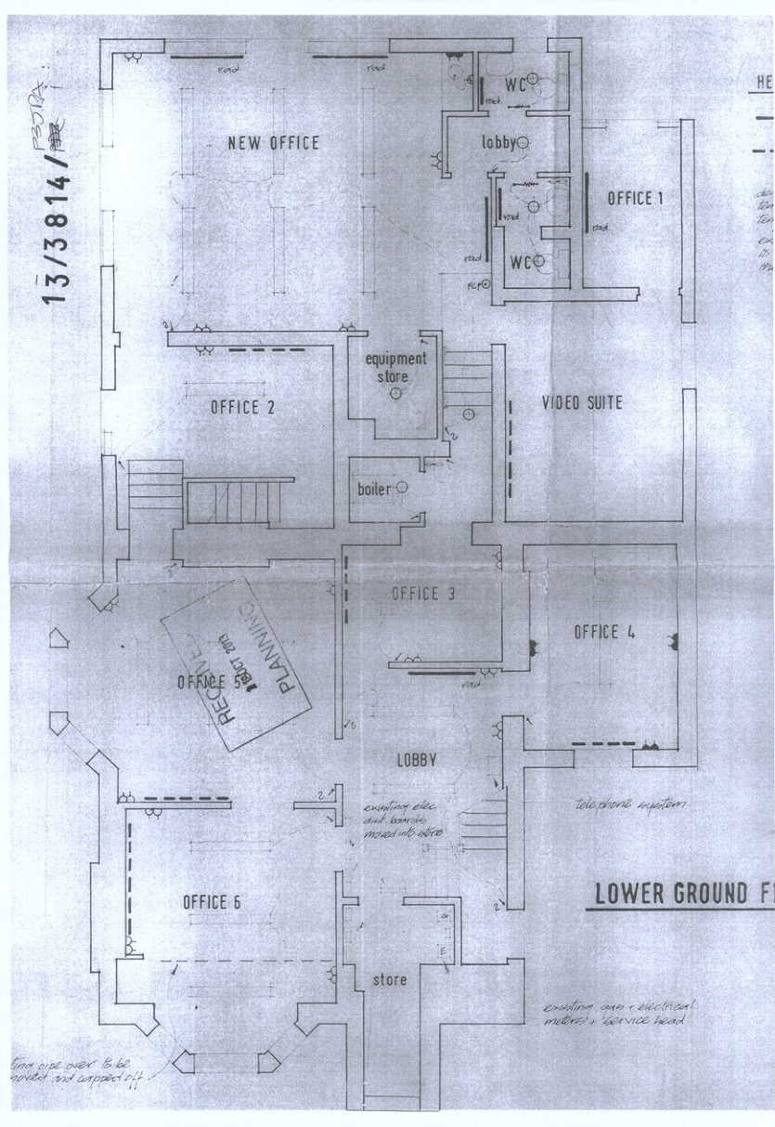

*Lower Ground Floor Plan*

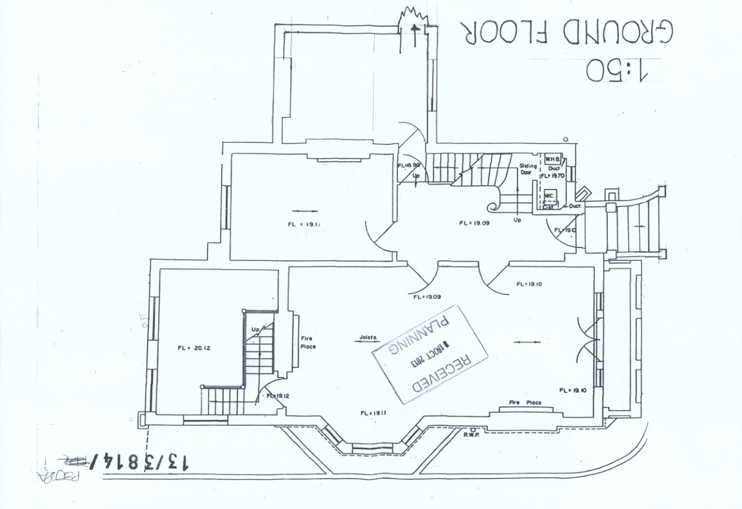

*Ground Floor Plan*

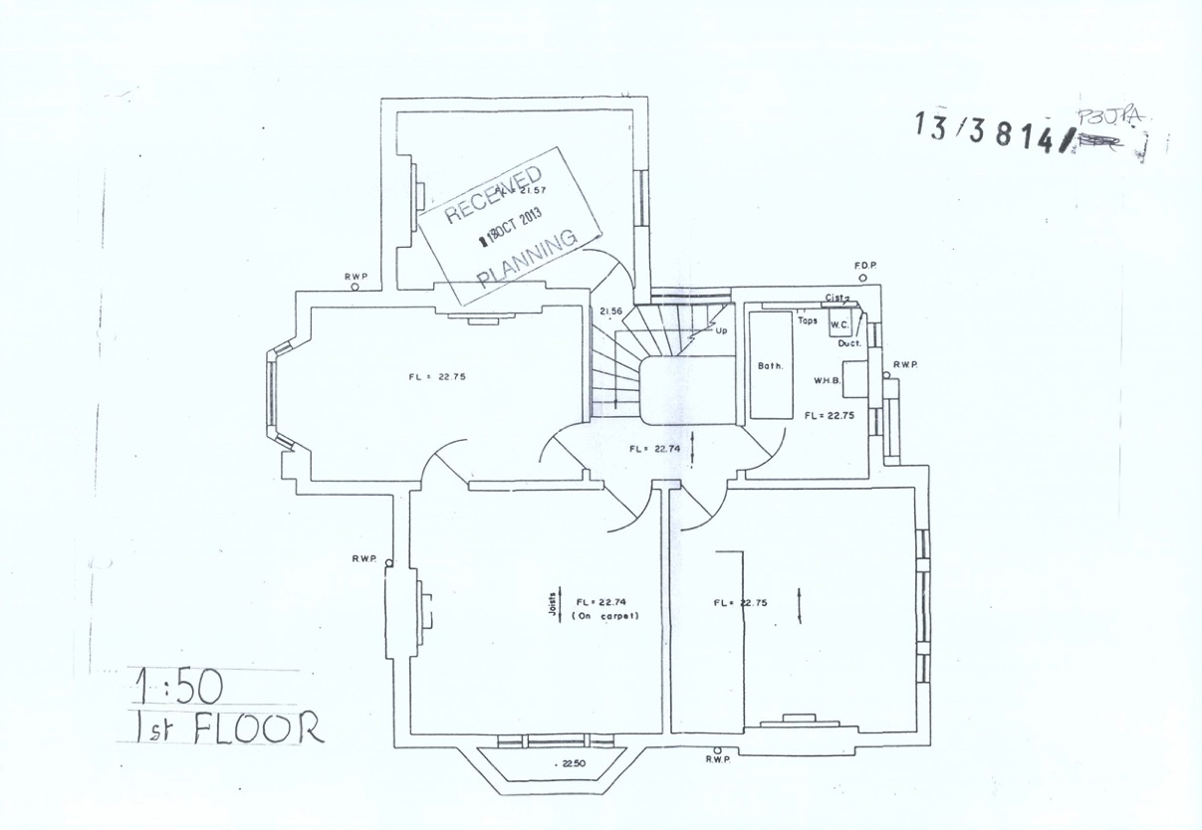

*First Floor Plan*

## Appendix 2: Planning Documents for The Broomhouse Studios (LBHF, 2013)

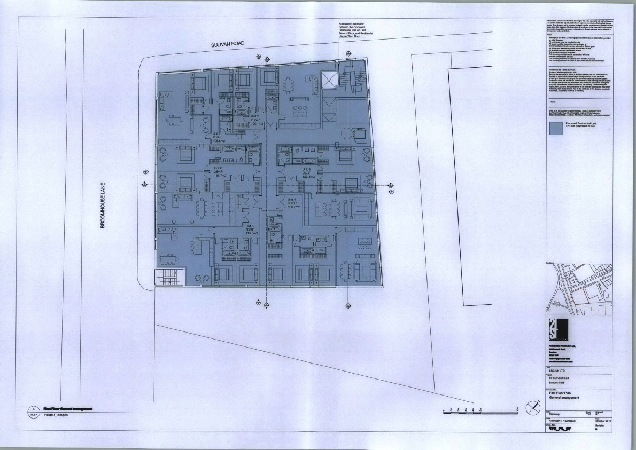

*First Floor Plan*

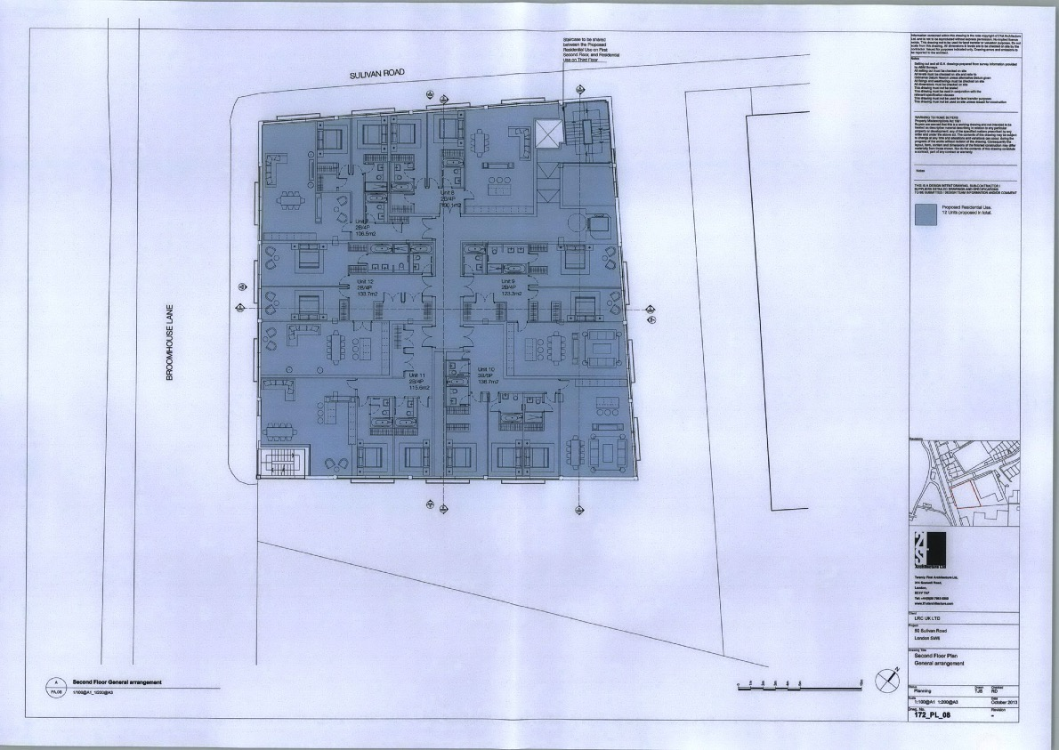

*Second Floor Plan*

1. A Section 106 Agreement (S106) is a planning obligation imposed upon land developers to ensure that they share some of the profits gained from developing the land with the local community. This can come in a variety of ways such as providing a number of affordable housing units, paying an agreed amount of money to the Local Authority and providing specific amenities that will benefit the surrounding community, such as a library
2. Unpublished python code, Jon Reades (2022)